Productivity / Accessibility Ribbon: Word 2010 Quick Accessibility Reference

File Tools
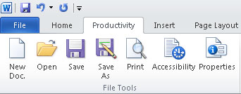
- New Doc – Creates a new document in the default template.
- Open – Opens an existing document
- Save – Saves the document with the current file name.
- Save as – Saves the document and prompts you for a new file name
- Print – prints the document
- Accessibility – Checks for common accessibility mistakes.
- Properties – Define meta data about the document to aid in searching.

Zoom
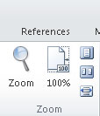
- Zoom – Set the magnification level
- 100% - Set magnification to 100%
- One Page – Display one page of the document.
- Two Pages – Display two pages side by side.
- Page Width – Display the document so that the width of the document matches the width of the window.

Structure
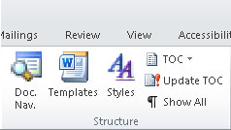
- Doc Nav – Opens an outline view of the document and allows heading navigation.
- Templates – Select or change the template for the document.
- Styles – Select headings, lists, and other styles to provide semantic structure for your document.
- TOC – Insert a table of contents
- Update TOC – Update the table of contents
- Show all – Show paragraph marks & breaks.

Lists
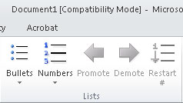
- Bullets – Create a bulleted list
- Numbers Create a numbered list
- Promote – Move the selected item(s) to the next higher level in a nested list.
- Demote – Move the selected item(s) to the next lower level in a nested list
- Restart # - Restart the numbering.

Layout
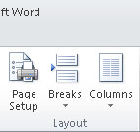
- Page Setup – Set up page size, orientation and margins.
- Breaks – Insert section breaks, column breaks, and page breaks.
- Columns – choose the number of columns for the page or the section

Tables
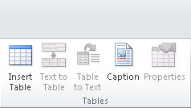
- Insert Table – Create a table at the cursor location.
- Text to table – Convert selected text to a table
- Table to text - Convert a table to text (left to right top to bottom).
- Caption – add a caption to a table, picture or other image
- Properties – Set the header row on a table, column size, row height, etc.

Language and Links
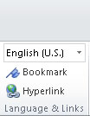
- Language drop down – set the language of the document or section.
- Bookmark – add linked bookmarks to a document.
- Hyperlink – add a hyperlink to a document and create meaningful link text

Forms
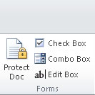
- Protect document – lock the document. Accessible forms (only allow filling in forms)
- Check Box – add a checkbox (does not work with all assistive technologies)
- Combo Box – add a combo box (does not work with all assistive technologies.
- ab|Edit Box – add an edit form field (works with all assistive technologies)

Pictures
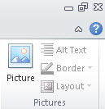
- Picture – insert a picture or diagram in a document.
- Alt Text – add alternative text to the description field in a document
- Layout – set the picture layout to in-line for maximum accessibility.

