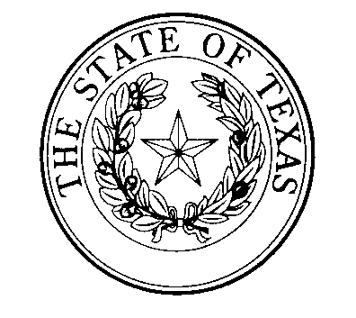
National Disability Employment Awareness Month
Texas Poster Art
SUBMISSION GUIDELINES

Eligibility and Media:
Each year in October, in recognition of National Disability Employment Awareness Month, the State of Texas and the Texas Governor’s Committee on People with Disabilities take the opportunity to recognize an outstanding artist with a disability who resides in the State of Texas. The person who is chosen as the featured artist will have his or her work prominently incorporated into the current year’s Texas NDEAM poster, which is distributed to businesses throughout the state, and will be a featured guest at the annual Lex Frieden Employment Awards ceremony. In addition, the featured artist’s piece (the original as well as the poster featuring the art) will be on display in the office of the Texas Governor’s Committee on People with Disabilities in Austin, and will occasionally be incorporated into other art exhibits sponsored by the State of Texas. The original artwork of the winning submission becomes the permanent property of the Texas Governor’s Committee on People with Disabilities.

There is no age limit or specific theme; a professional poster designer incorporates the winning art entry to tie in with the national NDEAM theme from the U.S. Department of Labor. Original 2D and 3D art in all media are eligible. The Texas Governor’s Committee on People with Disabilities will have the final authority as to what constitutes an acceptable entry. There is no entry fee, but all submissions must be accompanied by the formal submission form. Because the Governor’s Committee is committed to providing opportunities to as many Texas artists as possible, a previous NDEAM Poster Art winner will not be eligible for selection as a winner again until five years have passed since the artist’s previous win.

Entries:
Each artist should submit an entry in the form of a digital image on CD (jpeg or gif file), OR as a high-resolution photograph of the artwork, OR as an electronic version attached to an email to the address below. All entries must be accompanied by the required entry form completed in full and signed by the entrant; the signed entry form can be mailed to the address below or sent as a PDF attachment to the email address below. No more than THREE entries per artist, please. The deadline for entries is May 1st (electronic receipt or postmark). Send images and the completed Entry Form to:

NDEAM Poster
Texas Governor’s Committee on People with Disabilities
PO Box 12428
Austin, TX 78711
Email: GCPD@gov.texas.gov

Jurors:
A team of judges, selected by the Texas Governor’s Committee on People with Disabilities from the private and/or public sector, will collectively decide on the winner based on such criteria as Originality, Imagination, Visual Interest, and Skillful Use of Materials. The winner of the Texas NDEAM Poster Art contest will be notified by email or phone by June 1. Other entrants will be notified by email, postal mail, or phone by June 15.

Terms:
- Only Texas artists with disabilities are allowed to submit entries. A brief description of the artist’s disability must be included in the Entry Form.
- The winner of each year’s Texas NDEAM Poster Art contest will donate his or her original artwork to the Texas Governor’s Committee on People with Disabilities. The winner will complete and submit the appropriate paperwork designating the artwork as a gift to the State of Texas.
- An entry to this contest constitutes full agreement on the part of the artist to all conditions outlined in the Call for Entries, including donation of the artwork to the State.
- There will be no monetary compensation for the art. However, the original art will be reproduced for use in the current year’s Texas NDEAM Poster with a prominent acknowledgment of the artist.
- The winning artist grants the State of Texas permission to reproduce his or her artwork for non-profit distribution of the Texas NDEAM poster; all other rights to the image remain with the artist.
- The Texas Governor’s Committee on People with Disabilities will have final authority to define what constitutes an acceptable entry.
- The winning artist will be invited to and acknowledged at the annual Governor’s Committee on People with Disabilities’ Lex Frieden Employment Awards Ceremony. The artist will be acknowledged in a statewide press release.
- Copies of the poster with the featured art and artist’s statement will be distributed statewide, free of charge, to increase awareness of disability issues as well as appreciation of artists with disabilities.

For questions or more information, contact:

Governor’s Committee on People with Disabilities
PO Box 12428
Austin, TX 78711
Email: GCPD@gov.texas.gov
Phone: 512-463-5739 or Relay Provider of Choice

