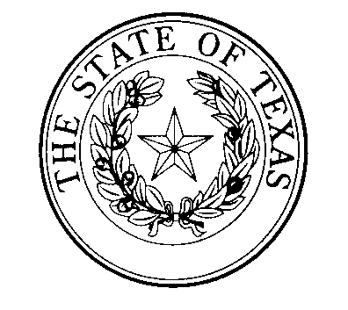

National Disability Employment Awareness Month
Texas Poster Art
SUBMISSION GUIDELINES

Eligibility and Media:
In recognition of National Disability Employment Awareness Month (NDEAM), every October the Governor’s Committee on People with Disabilities (GCPD) takes the opportunity recognize an outstanding Texas artist with a disability. The winning piece will be featured in the Texas NDEAM poster, which is used throughout the state to spark a conversation about the employment of Texans with disabilities. Submissions may be visual art of any subject matter, although judges may give special consideration to art that relates to employment.

The winning artist will have their work featured as the centerpiece of the current year’s Texas NDEAM poster, which will be distributed to businesses throughout the state. A professional poster designer will incorporate the winning piece into the poster and tie it in with the national NDEAM theme and Texas HireAbility campaign. In addition, the featured artist will be a guest at the annual Lex Frieden Employment Awards ceremony. The winning piece may also occasionally be featured in other art exhibits sponsored by the State of Texas.

Original 2D art (including but not limited to paintings or drawings), and 3D art (including but not limited to sculpture or pottery) in all media are eligible. The Texas Governor’s Committee on People with Disabilities will have the final authority as to what constitutes an acceptable entry. GCPD is committed to providing opportunities to as many Texas artists as possible; as such, a previous NDEAM Poster Art winner will not be eligible for competition until five years have passed since their last win.

Entries:
Each artist should submit an entry in one of the following formats:
- a digital image on CD (.jpg or .gif file),
- a high-resolution photograph of the artwork, or
- an electronic version attached to an email to GCPD@gov.texas.gov

Or the entry can be submitted by U.S. mail to the following address:
NDEAM Poster
Texas Governor’s Committee on People with Disabilities
P.O. Box 12428
Austin, TX 78711

There is no entry fee, but all entries must be accompanied by the required entry form completed in full and signed by the entrant. No more than THREE (3) entries per artist, please. The deadline for entries is July 26th (electronic receipt or postmark).

Jurors:
GCPD will select a team of volunteer judges from the private and/or public sector. They will collectively determine the winner based on criteria including originality, visual interest, and skillful use of materials. The winning artist will be notified upon final decision of the Governor’s Committee. A GovDelivery will also be distributed statewide to announce the winner.

Terms:
- Entries will only be accepted from Texas artists with a disability; a brief description of the disability must be included in the Entry Form.
- An entry to this contest constitutes full agreement on the part of the artist to all conditions outlined in the Call for Entries.
- The original art will be reproduced for use in the current year’s Texas NDEAM poster, including a statement and biography of the artist. There will be no monetary compensation for the winner.
- The winning artist grants the State of Texas permission to reproduce his or her artwork for non-profit distribution of the Texas NDEAM poster; all other rights to the image remain with the artist.
- The Texas Governor’s Committee on People with Disabilities will have final authority to define what constitutes an acceptable entry.
- The winning artist will be invited to and acknowledged at the annual Governor’s Committee on People with Disabilities’ Lex Frieden Employment Awards ceremony. The artist will be acknowledged in a statewide press release.
- Copies of the poster will be distributed statewide free of charge, in order to increase awareness of disability issues—including employment of people with disabilities and appreciation of artists with disabilities.

For questions or more information, contact:

Governor’s Committee on People with Disabilities
P.O. Box 12428
Austin, TX 78711
Email: GCPD@gov.texas.gov
Phone: 512-463-5739 or Relay Provider of Choice

