THE STATE OF TEXAS
GOVERNOR
To all to whom these presents shall come, Greetings:
Know ye that this official recognition is presented in recognition of the
32nd Anniversary of the Americans with Disabilities Act
July 26, 2022

The landmark Americans with Disabilities Act (ADA) was signed into law on July 26, 1990, by President George H.W. Bush, who called it a long overdue “independence day” for Americans with disabilities. The ADA was the first comprehensive civil rights law prohibiting discrimination against individuals with disabilities. It guarantees equal opportunity in public accommodations, employment, transportation, communications, and serves so that Americans with disabilities can more fully participate in society. The accessibility and inclusion ensured by the ADA empower all people to rise above their circumstances and achieve their dreams.

Thirty-two years later, census data show that there are over forty million Americans with a disability who benefit from this pivotal legislation. Through continued commitment to fairness and equality of opportunity, we can ensure a better, brighter future for all residents of the Lone Star State.

At this time, I am happy to celebrate the anniversary of the ADA and its manifold contributions to the disability rights movement. I am also proud to recognize the work of many dedicated Texans who helped to make this legislation a reality, from President Bush to ADA architect Lex Frieden and former Governor’s Committee on People with Disabilities Chair Justin Dart. Their unwavering commitment – as well as the dedication of countless others who support Texans with disabilities – has ensured that all people have an opportunity to pursue their own American Dream.

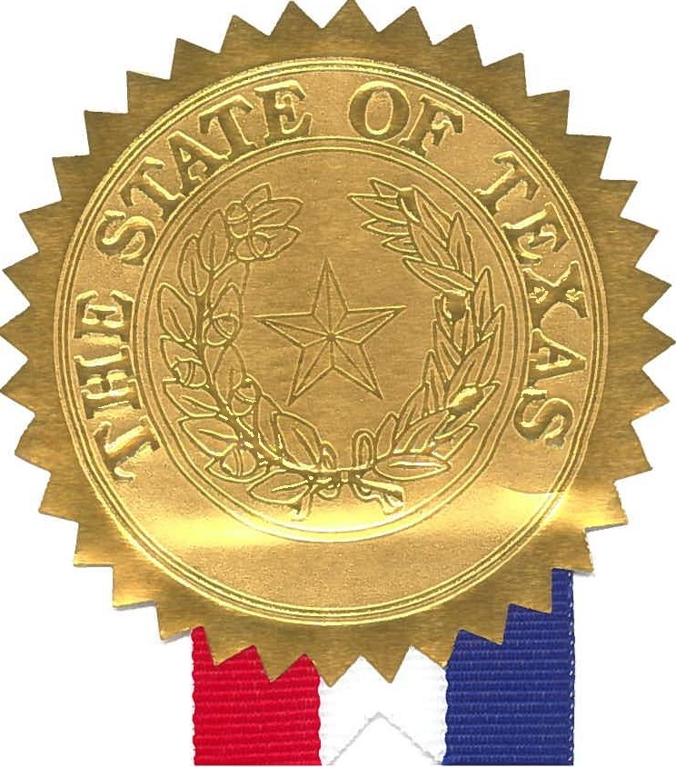
First Lady Cecilia Abbott joins me in encouraging all Texans to celebrate the anniversary of this historic legislation. Together, we can work to create a state that is accessible and inclusive for all Texans.

In testimony whereof, I have signed my name and caused the Seal of the State of Texas to be affixed at the City of Austin, this the 26th day of July, 2022.
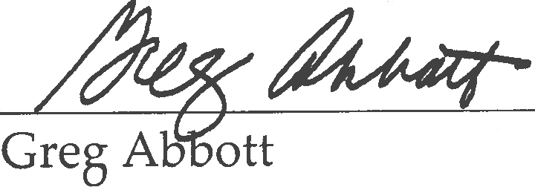
Governor of Texas

