Word 2010: How to Test Accessibility with JAWS
Contents
How to Test Accessibility with JAWS 1
Introduction 1
Accessibility Review 1
Common Key Commands 3
A Guide for Testing Your Document 3
Conclusion 4
Bibliography 4
Endnote 4

Introduction
Now that you’ve created your document following the accessibility requirements, it’s a good idea to test it using JAWS, or Job Access With Speech. JAWS is software that assists people with visual disabilities by reading text aloud. There are other assistive technologies, too, such as Non Visual Desktop Access (NVDA) and VoiceOver. However, this module only covers JAWS because it is most common in the workplace.
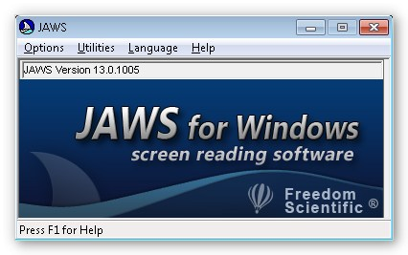
A cautionary note: The key commands mentioned in this module are based on the Windows 7 operating system with JAWS version 13.0 installed. If you have a different version or system, the commands may differ.

Accessibility Review
Recall from the module Requirements to Make a Word Document Accessible that there are seven accessibility considerations: structure, figures, hyperlinks, lists, columns, color and contrast, and tables.
JAWS can do more than read what’s on the screen; there are certain features that make skimming through a document or locating specific text very easy to do for JAWS users. Let’s take a closer look at how JAWS utilizes these seven requirements.
- Structure: A document’s structure is defined by applying heading styles. JAWS lists the document headings with the Insert+F6 command. The user can scroll through the list, select a heading, and move to that section within the document.
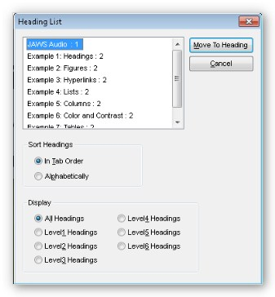
- Figures: JAWS reads the alternative text that describes a figure or image. To list labeled graphics, press Ctrl+Shift+O.
- Hyperlinks: JAWS announces linked text. It also lists all the hyperlinks in a document by using the Insert+F7 command. This is one of the reasons it is important to use meaningful text to describe the destination of the hyperlink.
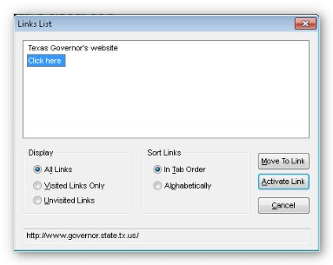
- Lists: JAWS is able to identify lists. It will either say, “bullet,” or the number of the item in the list before reading the item.
- Columns: JAWS will correctly read text in a column that was created with the Columns tool. If column spacing was formatted by the Tab key, JAWS will jump over the tab and read the text across columns as a regular line.
- Color and Contrast: JAWS reads all text, even if it is a white font on a white background. It will not tell you if you have good or bad color contrast, so be sure to familiarize yourself with the Color and Contrast module.
- Tables: For easy table navigation, the Insert+Ctrl+T command lists the tables in the document. Use arrow keys and Enter to select a table. Then press Insert+Spacebar, T to access the table layer. Use the arrow keys to move through the cells in the table, and Ctrl+Enter to move to the next table.

Common Key Commands
There are many hotkeys that are useful, but it is difficult to remember all of them. You can print the text version of this module to have a hard copy of some of the important commands. For a more extensive list of key shortcuts, visit the Freedom Scientific JAWS Keystrokes webpage.
JAWS uses the Insert key as a modifier key, which changes the function of another key. For example, Shift modifies lower case letters to be upper case. Use the Insert key just like you would use the Ctrl, Shift or Alt keys.
Here are some key commands that are commonly used:
- Ctrl silences JAWS until the next command.
- Ctrl+Down Arrow reads the next paragraph.
- Insert+5 says the word the cursor is on.
- Insert+5 twice spells the word.
- Ctrl+Alt+Page Up increases speech rate.
- Ctrl+Alt+Page Down decreases speech rate.
- Insert+F1 displays the Virtual Viewer. It shows the number of objects in the document, including whether or not there is a header or footer.

A Guide for Testing Your Document
Because a mouse is a visual device, the keyboard is the primary control tool for navigating JAWS. If you are an experienced user and are comfortable with JAWS, you may want to consider unplugging the mouse and turning off the monitor to have a better feel for how accessible—or inaccessible—your document really is. This is not recommended for first-time users.
JAWS will start talking before you even log on. Keep in mind that this is software used by people with visual disabilities, so the computer will be talking a lot during setup to describe what’s on the screen. It’s a good idea to use headphones to not bother co-workers around you.
Here is a general guideline for testing accessibility with JAWS.
- Open your document.
- Experience your document with JAWS. Start JAWS, then:
  - Listen to the entire document. The command to read from where the cursor lies to the end of the document is Insert+Down Arrow. To read the full document, make sure the cursor is at the beginning of the first line. Otherwise, you can use the Down Arrow to scroll through the document line by line.
  - Scan the list of headings provided by the Insert+F6 command.
  - Review linked text by pressing Insert+F7.
  - Check that every image includes alt text by using the Ctrl+Shift+O command.
  - Examine tables for easy navigation. Be sure you can access the table layer. Press Insert+Spacebar, T to access the table layer.
- Check your document’s functionality.
  - Make sure links take you to the correct destination. With the cursor on the linked text, press Enter.
  - If there are form fields on the page, fill them out. You can navigate through the document and type information in the field boxes. Make sure the prompt for the form field makes sense and matches the onscreen text (they can be different). A faster way to fill out the form is to press Insert+F5, and the Form Field dialog box will appear. Scroll through the list of fields using the Arrow keys and press Enter to jump to that field box.
  - If your document includes dropdown lists or checkboxes, make sure that they are announced and work properly. Press Alt+Down Arrow to open a dropdown box, Arrows to move within it, and Enter to select an item. For a checkbox, press the Spacebar to check or uncheck it.

Conclusion
This module covered the basics of testing accessibility using JAWS version 13 on a Windows 7 machine. Although the specific key commands might vary if you use different versions, the overall approach is the same: make sure that JAWS can read your document and all features are understandable. This concludes our module on How to Test Accessibility with JAWS.

Bibliography
Pound, Pat. “Tips and Tricks—Testing Your Website with the Screen Reader ‘JAWS’.” April 10, 2007.
Richwine, Brian. “Accessibility Test.” Sakai 2.8 Accessibility Testing Protocol Using JAWS Screen Reader. Sep 29, 2010. https://confluence.sakaiproject.org/display/2ACC/Sakai+2.8+Accessibility+Testing+Protocol +Using+JAWS+Screen+Reader.

Endnote

http://www.freedomscientific.com/doccenter/archives/training/JAWSKeystrokes.htm

