Understanding Assistive Technology
Contents
Understanding Assistive Technology 1
What is it? Who uses it? 1
A-T for people who are blind or visually impaired 1
A-T for people who are deaf or hard of hearing 2
A-T for people with dexterity issues 2
A-T for people who have difficulty concentrating, understanding or processing text 3
Conclusion 3

What is it? Who uses it?
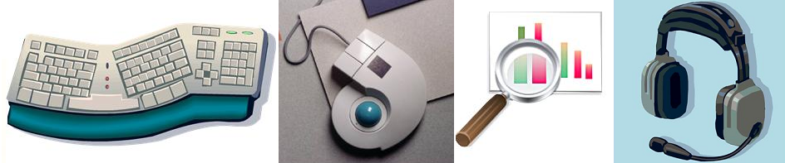
We all have different functional abilities. Some of us are great typists and others struggle to find the keys. Some of us use multiple monitors to help us organize our work, while others function very efficiently with a mobile device. We may use ergonomic keyboards to make typing easier, spell check software to assure document quality, or voice recognition software to dial a phone while our hands are busy.
Assistive technology, or A-T, is technology used by people with disabilities to accomplish tasks that might otherwise be difficult or impossible. This can be as simple as a specially-designed mouse or trackball, a spell checker, or an adjustable chair; or as complex as a screen reader, screen magnifier, Braille display, or speech recognition software.

A-T for people who are blind or visually impaired
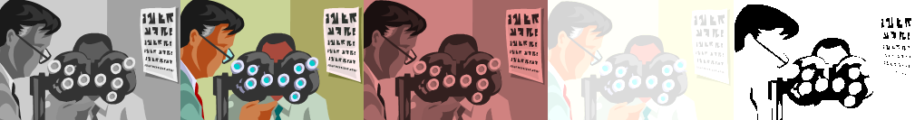
Although you may not know someone who is totally blind, you or someone you know may be color blind, have a need to increase the font size of some documents, be sensitive to lighting conditions, or need bifocals.
Microsoft Office programs offer features that provide direct assistance like increasing magnification, or the ability to change the font face, color or size. The operating system also allows people to choose high contrast color schemes.
Screen magnification software allows people to achieve much greater levels of magnification and control over foreground and background colors. For people with significant vision loss screen reader software can read the text of a document or spreadsheet, and if the document is created correctly can also let the user scan a document through headings, understand relationships of data in tables and visualize graphics. Screen readers translate documents into speech or Braille but depend on the document creator to ensure all of the information can be translated.

A-T for people who are deaf or hard of hearing
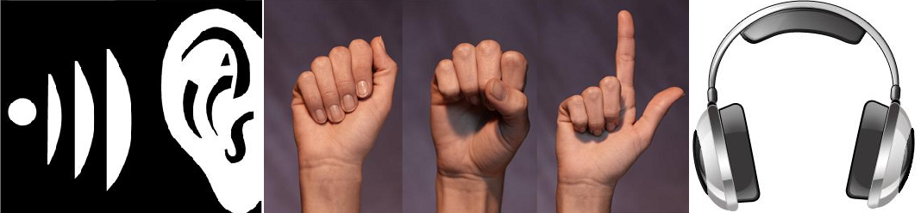
Hearing impairment can range from slight hearing loss to total deafness. It may also be a loss in specific frequency ranges (not being able to hear high pitched sounds, for instance) or not being able to separate out the voice of the person you are listening to when you are in a loud environment.
People with hearing limitations may wear hearing aids, increase the volume of audio, or require captions for video, transcripts of audio, or sign language interpretation.
Captions and transcripts are alternative methods of presenting audio information. These alternative presentations must be created by the author of the content in order for people with hearing impairments to benefit from audio information.
For many people who are deaf, American Sign Language, or ASL, is their first language. ASL is not the same as English. Writing your documents using plain language will help these people and others for whom English is a second language better understand the information that you are trying to present.

A-T for people with dexterity issues
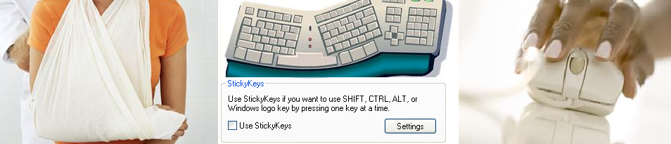
Arthritis may limit someone’s ability to reach multiple keys at the same time or to type comfortably. Parkinson’s or brain injury may make it nearly impossible for someone else to accurately position the mouse cursor over a link or button control. You may use an ergonomic keyboard to lessen fatigue and minimize your risk of carpel tunnel syndrome. Sticky keys allow people to press a series of keys sequentially to mimic a single multi-key command. Intelligent software can distinguish between a hand tremor and deliberate mouse movement to help people more accurately use a mouse or other pointing device. Speech-to-text software allows people to ignore the keyboard and mouse altogether and just speak to the computer telling it what to do or what to type. The use of word prediction software, where a list of words is suggested after typing the first few letters of a word, may help people type more efficiently.

A-T for people who have difficulty concentrating, understanding or processing text
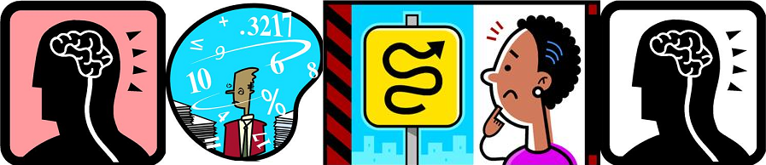
There are many neurological conditions that may affect someone’s ability to learn, listen, read, write, concentrate, or process information. These disabilities may not be apparent to others.
The impact of these conditions may change depending upon the work demands and environmental conditions (for example, lighting, noise, visual distraction, or interruptions). People with these conditions can benefit from a wide variety of tools including spell check, grammar check, and word prediction software. They may also use software and operating system controls to simplify the interface, or other assistive technologies like dictation software or text-to-speech software to assist with writing or reading.

Conclusion
There are many aids, software, and hardware tools that can compensate for the functional limitations that all people have. These tools make the creation and processing of information easier for people. These tools only work as well as the information provided by authors. If a video does not have captions, it is meaningless to a person who cannot hear. Headings and other structure in a document help people using screen readers or who have reading difficulties. If an image or chart does not have text describing it, assistive technology cannot provide that information. It must be provided by the author. A-T only assists in the presentation of information. It cannot create the alternative representations necessary for people with disabilities to gain meaning from the content. Nor can it add or create headings or any other information necessary for all users to make sense of it.

