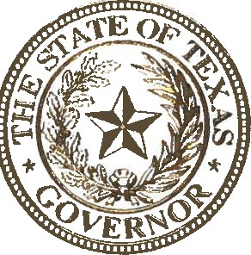
STATE OF TEXAS
OFFICE OF THE GOVERNOR
A booming economy and a business-friendly climate have long made the Lone Star State a bastion of prosperity, and Texas’ economic philosophy is guided by an abiding concern for the men and women who constitute our workforce. Our economic apparatus is meant to be a vehicle through which people from all walks of life can use their skills and effort to better themselves and their communities. As such, the state has prioritized the removal of economic stumbling blocks such as burdensome regulations and exorbitant taxes so that all Texans can chart their own course and improve their lot in life. If, however, we are to integrate more Texans into this vision of prosperity, we must acknowledge the unique needs and obstacles facing Texans with disabilities. These men and women demonstrate strength and resilience on a daily basis, and they make enormous contributions to our state, our civic life, and our economy. People with disabilities throughout Texas serve as living proof that our circumstances need not define us. Those with disabilities can accomplish any goal to which they aspire—up to and including the governorship of our great state.

For decades, advocates and activists have made tremendous progress in pursuit of equality for people with disabilities, but much work remains. In Texas, there are nearly two million working-age people with disabilities, yet they are nearly twice as likely as their able-bodied counterparts to be unemployed. Ultimately, we know that in Texas it is not our challenges that define us, but rather how we rise above them, and by providing appropriate resources, making reasonable accommodations, and improving awareness, we can give every Texan an equal opportunity to contribute to the workforce. All Texans—regardless of disability status—have a role to play as we build the Texas of tomorrow, and we must all do our part to ensure that no disability stands between Texans and their dreams.

Every year, the month of October is set aside to celebrate Texans with disabilities and their indispensable contributions to the Lone Star State’s workforce. During this month, we recommit ourselves to promoting disability employment awareness, cultivating more inclusive workplaces, and creating more employment opportunities for Texans with disabilities. As we work toward these goals, we will create a more robust economy and a stronger, more inclusive state. At this time, I encourage all Texans to join me in recognizing and commending the many achievements of Texans with disabilities who have helped build a better, brighter future for our great state.

Therefore, I, Greg Abbott, Governor of Texas, do hereby proclaim October 2022 to be

Disability Employment Awareness Month

in Texas and urge the appropriate
recognition whereof.

In official recognition whereof,
I hereby affix my signature this the
19th day of September, 2022.

Greg Abbott
Governor of Texas

