THE STATE OF TEXAS
GOVERNOR
To all to whom these presents shall come, Greetings:
Know ye that this official recognition is presented to all observing
World Braille Awareness Day
January 4, 2022
Since its creation by Louis Braille nearly two hundred years ago, braille has offered new levels of accessibility and independence for people across the globe who are blind or visually impaired. World Braille Awareness Day serves as a reminder for all of us about the importance of accommodating the needs of everyone in our community, because, in doing so, we can ensure that our great state will continue to be the best place to live, work, and raise a family for all Texans.

For Texas to continue on its path of success, it is vital we remain focused on the work that remains before us to create a fully inclusive and accessible state for Texans with disabilities. Across our state, Texans who are blind or visually impaired live lives that exemplify the remarkable qualities of the indomitable Texas spirit – courage, independence, and ingenuity – and braille plays a crucial role in helping these invaluable Texans contribute to a better and brighter future for our state and nation.

At this time, I encourage all Texans to learn more about the many ways in which braille and other accessible forms of communication improve the lives of Texans across the Lone Star State.

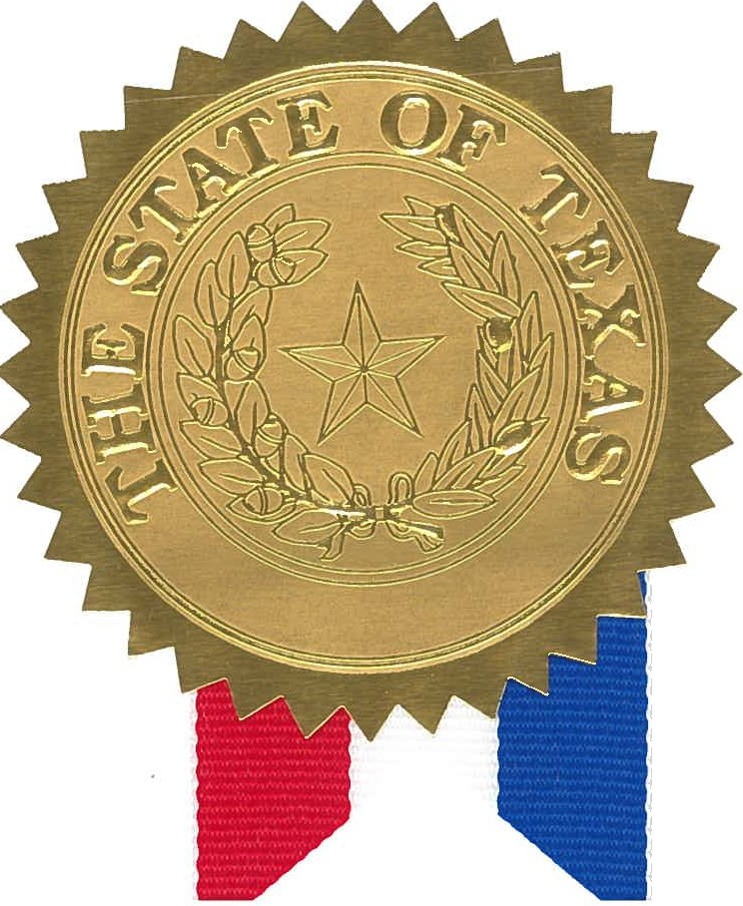
First Lady Cecilia Abbott joins me in wishing you the best.

In testimony whereof, I have signed my name and caused the Seal of the State of Texas to be affixed at the City of Austin, this the 14th day of December, 2021.

Greg Abbott
Governor of Texas

