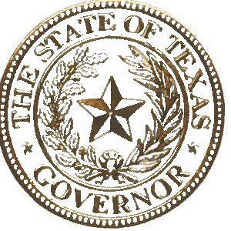

STATE OF TEXAS OFFICE OF THE GOVERNOR

The life of Helen Keller, history's most famous person with both hearing and vision loss, helps all Americans understand that people who are DeafBlind are incredibly resilient and can achieve greatness despite the challenges they face. After losing her sight and hearing at 19 months of age, Ms. Keller developed her own signs with the support of her teacher Anne Sullivan and grew into a woman who read five languages, attended Radcliffe College at Harvard University, wrote books, and traveled the world.

Her inspiring life and incredible personal gifts had an enormous impact in bringing awareness to the DeafBlind community. Ms. Keller's life and work helped our state and nation understand the vital importance of encouraging and supporting individuals with multisensory disabilities to fully participate in our society. Her life and fierce advocacy for people with disabilities showed America and the entire world that the accomplishments and achievements of people who are DeafBlind know no limits. Combined vision and hearing loss poses large barriers to communication, but Texans in the DeafBlind community exemplify the indomitable spirit and can-do attitude of the Lone Star State by pursuing excellence with the same unyielding and determined spirit as Helen Keller did through her life.

We have made significant progress in ensuring that individuals who are DeafBlind have the tools they need to realize their potential, from supporting employment access, housing and recreational options, and supportive technological devices for people who are DeafBlind so that they have the opportunity to fully participate in our communities. Additionally, today's DeafBlind community has access to specially­ trained interveners and support service providers who supply the best possible opportunities to communicate, access information, and participate fully in their communities. While Texas has made progress toward a better future, the work is not finished.

At this time, I encourage all Texans to participate in this year's DeafBlind awareness campaign by commemorating Helen Keller's life, acknowledging the many contributions of Texans with disabilities, and learning how to best offer support to Texans with this disability. Our continued support of all individuals with disabilities, including Texans who are DeafBlind, is essential to ensuring a brighter future for the Lone Star State.

Therefore, I, Greg Abbott, Governor of Texas, do hereby proclaim June 26 - July 2, 2022, to be

Helen Keller DeafBlind Awareness Week
in Texas and urge the appropriate recognition whereof.

In official recognition whereof,
I hereby affix my signature this the 24th day of May, 2022.

