THE STATE OF TEXAS
GOVERNOR
To all to whom these presents shall come, Greetings:
Know ye that this official recognition is presented to all observing
Global Accessibility Awareness Day
May 19, 2022

The Lone Star State is home to many Texans with disabilities and impairments who live lives exemplifying the remarkable qualities of our indomitable Texas spirit – courage, independence, and ingenuity. For Texas to continue on its path of success, it is vital we remain focused on working to ensure our state is fully accessible for all Texans. However, people with disabilities still encounter difficulties online due to a lack of accessibility features. Inclusive digital access and design plays a crucial role in helping our invaluable Texans with disabilities easily contribute and live productive lives while online, and it is important that we continue to support online accessibility features.

Global Accessibility Awareness Day serves as a reminder – for all of us – about the importance of accommodating the needs of everyone in our community, because, in doing so, we can ensure that our great state will continue to be the best place to live, work, and raise a family. At this time, I encourage all Texans to learn more about the many ways in which inclusive digital access improves the lives of Texans across the Lone Star State.

First Lady Cecilia Abbott joins me in wishing you the best.

In testimony whereof, I have signed my name and caused the Seal of the State of Texas to be affixed at the City of Austin, this the 9th day of May, 2022.
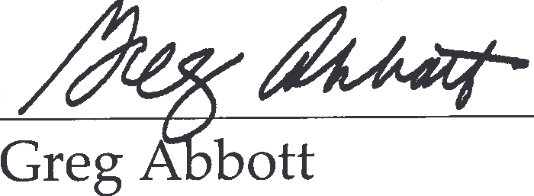
Governor of Texas

