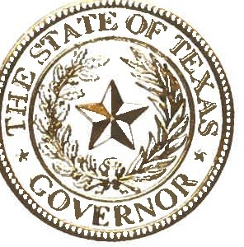

STATE OF TEXAS
OFFICE OF THE GOVERNOR

An estimated 480,000 individuals in Texas have developmental disabilities. The hopes and dreams of Texans affected by developmental disabilities do not differ from the aspirations of all in our state-to be self-sufficient, work and earn a living, practice their faith, and support their community. Like all Texans, people with developmental disabilities have unique skills and experiences that fortify our state's rich diversity, and throughout our history these Texans have made substantial contributions that make the Lone Star State a better place for us all.

There is no doubt that Texas is better when every citizen is able to flourish in their community. Students with developmental disabilities who are included in classroom settings outside of special education are more likely to realize their full academic potential. When people with disabilities are included in the workforce, they have an opportunity to earn a competitive wage, work as part of a team, and support our state's strong economy. People with developmental disabilities who are involved in their community generally live longer, healthier lives and are more likely to give back to their communities. When inclusion becomes a way of life, Texas' communities thrive.

Each year, we dedicate the month of March to raising awareness about developmental disabilities and emphasizing the importance of including people of all abilities in every aspect of our life. During this month, Texans can raise awareness about how classrooms, workplaces, houses of worship, and communities are stronger when they include people of all abilities. At this time, I encourage Texans to come together to increase awareness about developmental disabilities and support full inclusion and equality for all.

Therefore, I, Greg Abbott, Governor of Texas, do hereby proclaim March 2022 to be

Developmental Disabilities Awareness Month

in Texas and urge the appropriate recognition whereof.

In official recognition whereof,
I hereby affix my signature this the 161h day of February, 2022.

