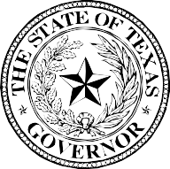

GOVERNOR GREG ABBOTT

Texans with disabilities demonstrate remarkable qualities characteristic to the indomitable Texas spirit: courage, independence, and ingenuity. Throughout our state’s rich history, these Texans have filled our highest offices, fought in historic battles, enriched local communities, and contributed greatly to our traditions and culture. Our state is made better by the unique perspectives, passions, and dedicated work of Texans with disabilities.

The disability community has a critical interest in policies enacted at local, state, and national levels, because these policies affect the integration of people with disabilities, young and old, into our communities. Texans with disabilities sometimes face challenges in accessing their right to vote, so we must ensure they have adequate opportunities to engage in this civic duty. Voting is one way Texans with disabilities can make their voices heard and help shape public policy to meet the real needs of the disability community.

Each September, we recognize one week as National Disability Voter Registration Week in order to raise awareness of this important cause. At this time, I encourage all Texans to support the many efforts which highlight the importance of voting rights for the disability community and to learn more about voter registration and accommodations available to voters with disabilities. We are a stronger state when all Texans are involved in the democratic process.

Therefore, I, Greg Abbott, Governor of Texas, do hereby proclaim September 13-20, 2021, to be

Disability Voter Registration Week

in Texas, and urge the appropriate recognition whereof.

In official recognition whereof,
I hereby affix my signature this the 1st day of September, 2021.

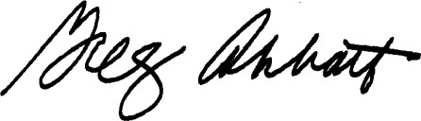

Governor of Texas

