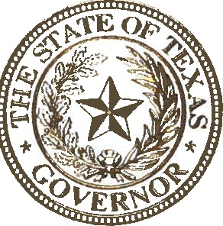

STATE OF TEXAS OFFICE OF THE GOVERNOR

The often-used slogan for the Lone Star State's approach to commerce is that "Texas is wide open for business." This openness and dedication to inclusion and diversity in business has long been a truly Texan staple of our strong economy. It is crucial for this diversity to extend beyond our business climate to the hardworking men and women who make up the robust Texas workforce.

An important part of this workforce are Texans with disabilities: strong, resilient workers who make invaluable contributions to our state and economy on a daily basis. Not only must we enhance Texas' workforce so it better serves Texans with disabilities, we must also engage in disability employment awareness to ensure all Texans have an equal opportunity to contribute to the workforce and participate in building the Texas of tomorrow.

Every year, the month of October is dedicated to celebrating and recognizing the indispensable contributions Texans with disabilities provide to the Lone Star State's economy. During this month, we also recommit ourselves to promoting disability employment awareness, creating more inclusive workplaces, and cultivating more employment opportunities for Texans with disabilities. As we work toward these goals, our economy will continue to be strengthened by the many contributions of workers with disabilities.

At this time, I encourage all Texans to join me in recognizing and commending the many achievements of Texans with disabilities who have helped build a better and brighter future for our great state.

Therefore, I, Greg Abbott, Governor of Texas, do hereby proclaim October 2021 to be

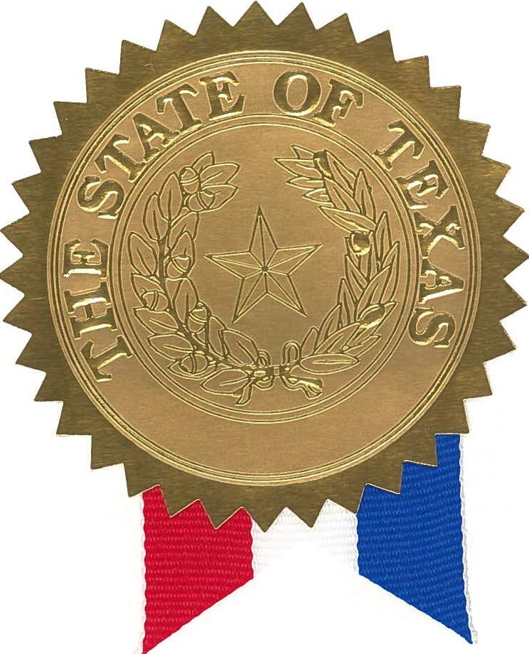
Disability Employment Awareness Month

in Texas, and urge the appropriate recognition whereof.

In official recognition whereof,
I hereby affix my signature this the 1st day of September, 2021.

