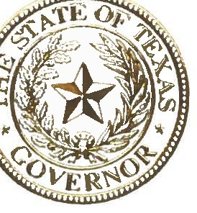

STATE OF TEXAS
OFFICE OF THE GOVERNOR

The Lone Star State is filled with stories of Texans with disabilities who have enriched our state. With the passion, unique perspective, and shared experiences of Texans with disabilities, including Texans who are deaf and hard of hearing, our state has become stronger and more inclusive. It is important to honor the legacy of these remarkable Texans and highlight their lasting contributions to our great state.

In Texas, we know that it is not our challenges that define us, but rather how we rise above them. Our state's history has been shaped by Texans who are deaf and hard of hearing, many of whom left a lasting mark on our state, including Erastus "Deaf' Smith, famed for his role in the Texas Revolution. Texans who are deaf and hard of hearing are resilient, resourceful, and truly embody the indomitable spirit and can-do attitude of the Lone Star State. Many of these hardworking individuals provide health care services, educate and mentor our Texas schoolchildren, build and maintain our infrastructure, and play important roles in our booming economy.

Each September, organizations across Texas dedicate a week to raise awareness on behalf of our fellow Texans who are deaf and hard of hearing in order to promote available resources for the education and effective communication needed for these Texans. At this time, I encourage all Texans to recognize, support, and celebrate the many unique achievements of those who are deaf and hard of hearing. I thank the many professionals and educators who assist, support, and advocate for their fellow Texans, and for their contributions focused on aiding those who are deaf and hard of hearing in Texas. Together, we can ensure a better and brighter future for the Lone Star State.

Therefore, I, Greg Abbott, Governor of Texas, do hereby proclaim September 19- 25, 2021, to be

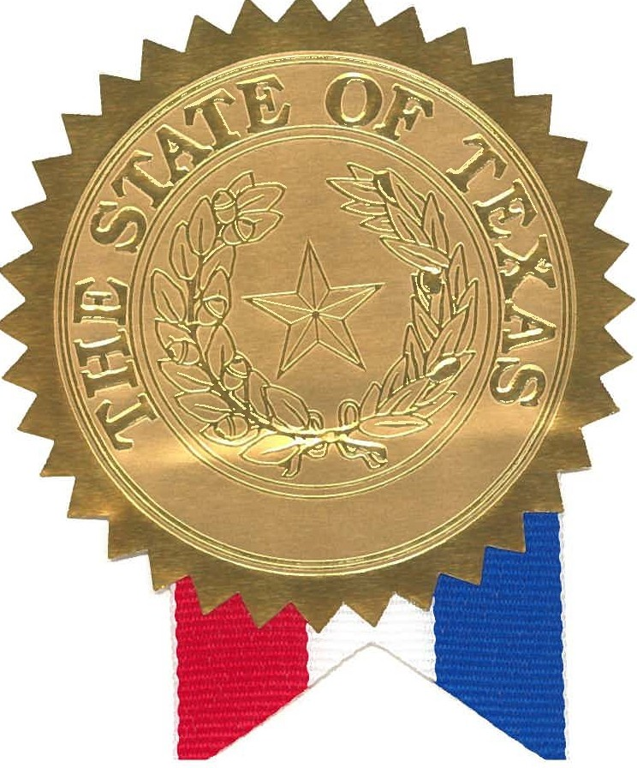
Deaf Awareness Week

in Texas, and urge the appropriate recognition whereof.

In official recognition whereof,
I hereby affix my signature this the 16th day of September, 2021.

