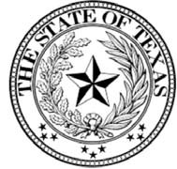
STATE OF TEXAS
OFFICE OF THE GOVERNOR

The often used slogan for the Lone Star State’s approach to commerce is that “Texas is wide open for business.” This openness and welcoming atmosphere has been a major part of the foundation for our strong economy. Thus, it is crucial that we ensure this welcoming atmosphere applies not only to our business climate but to the hardworking men and women who make up the indomitable Texas workforce.

An important part of this workforce is Texans with disabilities, who make invaluable contributions to Texas employers. In light of this, while we strengthen our state’s workforce system to prepare Texans with disabilities for the jobs of the 21st century, we must engage in disability employment awareness to ensure that all Texans have the equal opportunity to contribute to the workforce that is the backbone of our great state’s robust economy.

That is why this October is dedicated to Texans with disabilities. During this month, we dedicate ourselves to promoting disability employment awareness, creating more inclusive workplaces and creating more employment opportunities for Texans with disabilities to support an economy that is made ever stronger by the diversity and full participation of workers with disabilities.

Not only as the governor of the Lone Star State, but as a Texan with a disability myself, I encourage all Texans to learn more about disability employment and join me in celebrating the varied accomplishments of Texans with disabilities that have contributed to building an even better and brighter future for our great state. Texas employers can find additional resources on how to promote disability employment awareness through the Texas HireAbility Campaign, which raises awareness about the benefits of hiring people with disabilities and highlights the contributions of people with disabilities in the workforce.

Therefore, I, Greg Abbott, Governor of Texas, do hereby proclaim October 2017 to be
Disability Employment Awareness Month

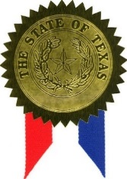 | in Texas, and urge the appropriate recognition whereof  In official recognition whereof, I hereby affix my signature this the 28th day of September, 2017.  Greg Abbott  Governor of Texas

