PowerPoint 2010: Adding Tables, Charts, Images, and Shapes
Contents
PowerPoint 2010: Adding Tables, Charts, Images, and Shapes 1
Introduction 1
Tables 1
Images 3
Charts 4
Shapes 5
One More Thing 5
Summary 6

Introduction
In the previous PowerPoint module, we discussed accessibility considerations for live presentations and general concepts for making your PowerPoint presentations and handouts accessible. In this module, we discuss details on how to make tables, charts, images, and shapes accessible in a PowerPoint presentation.

Tables
Data tables are used to display text in a grid with rows and columns. A header at the top of each column or at the beginning of each row helps the reader understand what type of information is provided.
We recommend following these guidelines when creating a data table on a slide.
- When you insert a table, use the Insert Table option and not the Draw Table option. When using one of the standard slide layout templates, click on the Insert Table option provided in a content placeholder, or go to the PowerPoint ribbon’s Insert tab and select the Insert Table option.
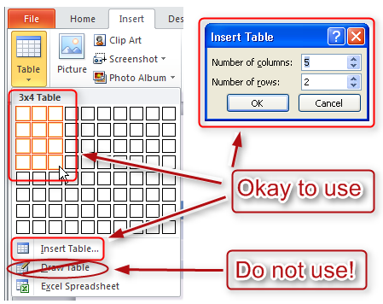
- When you insert the table, notice that the Table Tools Design tab opens in the ribbon.
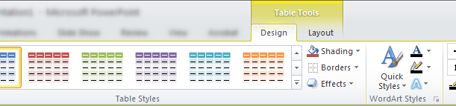
Select a table style that sets the text, background, and grid colors for the table. When selecting a style, consider the following issues:
  - Be sure there is enough contrast between the text and background colors of each cell. See the Colors and Contrast training module for more tips on selecting text and background colors.
  - Choose a table style that provides grid lines to separate the data cells. If someone is using a screen magnifier to view the slide, the grid lines help them follow each row across the page, especially if there is a lot of space between the text in adjacent cells. The grid lines are also useful for separating cells if there is a lot of text.
- Use simple data tables. Never merge two or more cells into a single larger cell or split a cell into smaller cells. The table should be a simple grid with predictable rows and columns. Complex table structure is nearly impossible to follow with a screen reader.
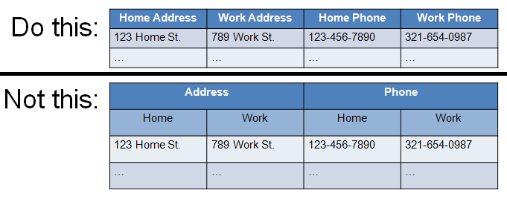
- Provide column headers for your data table. This helps people understand the meaning of each column of data. Type the column header text into the first row of the table, and be sure to select the Header Row option on the Table Tools Design tab.
- Add alt text to make your table more accessible. To add alt text, right click within the table, select the Format Shape option, and then select the Alt Text tab. To get to the Alt Text dialog using the keyboard, first tab to the table in the PowerPoint edit area and press Shift+F10, select Format Shape, then select Alt Text. Leave the Title field blank, and enter a very short description in the Description field.
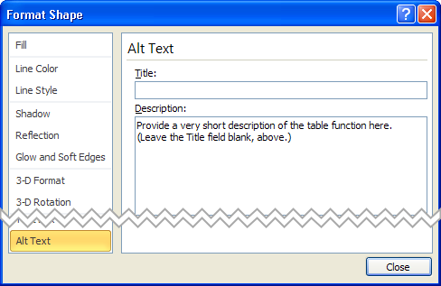
- Don’t leave columns or rows blank. If someone is listening to a screen reader announce the information in the table, they may think the table has ended if they encounter a blank row. If you want to provide more separation between rows, you can increase the height of each row using the Table Row Height control in the Table Tools Layout ribbon.
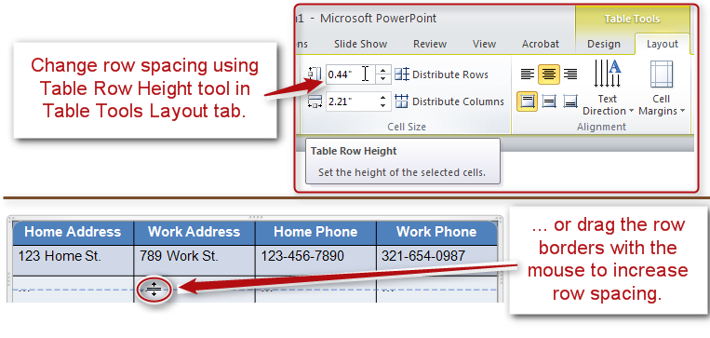
Screen readers do not work well with tables in PowerPoint files, but the techniques we discussed will help make your tables as accessible as possible.

Images
Just like PDF and Word documents, you must add alt text to images in your PowerPoint slides. This lets people who are using a screen reader know what the images are.
The procedure for adding alt text to an image is similar to that in Word. Right click on the image, or tab to the image and press Shift+F10, to open the context menu, choose the Format Picture option, and open the Alt Text tab. Type a description of the picture in the Description field. You can leave the Title field blank. Sometimes PowerPoint will automatically add the file name of the image in the Alt text field. This is not useful information, and should be replaced with text that is meaningful.
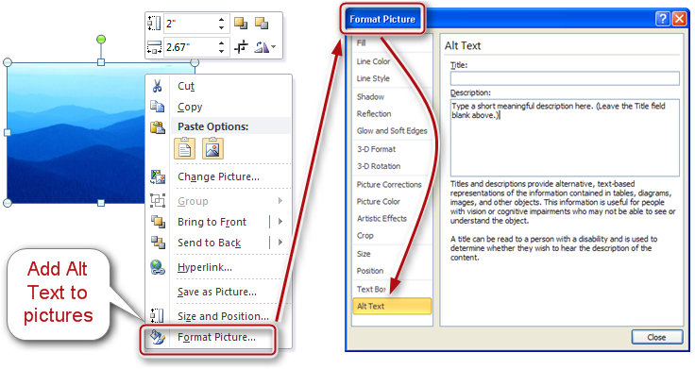
Remember to keep the description short. Decide what you expect people to learn from the picture, and add just enough information to tell them what they need to know.
Also, do not place text over a picture or watermark. This may cause problems for many people, but those with limited vision may find it particularly hard to distinguish the text from the patterns and colors of a background image.

Charts
Charts, graphs, and other complex images may contain so much information that it is difficult to sufficiently describe them with Alt Text.
You can approach this problem in several ways.
- First, consider whether it is possible to simplify the chart, or split it into multiple charts, so that each one contains a smaller amount of information. This will not only simplify the alt text required for each chart, but will make the information more understandable for everyone in your audience.
- If the image is still too complex to describe the alt text, you will need to provide a text description elsewhere. One possibility is to add the full description to the Notes section of the slide. If you do this, add alt text to the picture with a very short description of the picture, and end with the words "Full text description in the Notes section of this slide." You can even place that note on the slide itself, so even people who do not use screen readers can find the text description.
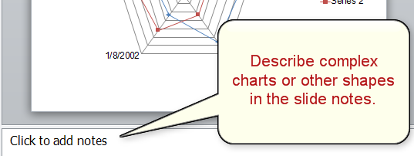
- Another possibility for describing a complex picture is to type the description into a text box placeholder on the slide, and then place the picture OVER the text, so that only the picture is visible on the slide. In that case, you will again add a very short description of the picture to the alt text, but this time end with the words "Full text description is found in the slide text." The screen reader will announce the hidden text even though it is not visible on the slide.
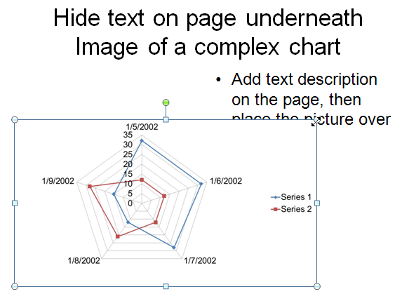

Shapes
PowerPoint also allows you to add shapes to a page. The Insert Shapes dialog has a number of geometric shapes, arrows, equation signs and more that you can add to a page. Some of the shapes, like the speech bubbles, allow you to type text into them, while other shapes, like the arrows, do not. But all shapes allow you to add alt text by right clicking on the shape and opening the Format Shape option. If you are using the keyboard, tabbing to the shape and pressing Shift+F10 does the same thing as right-clicking with the mouse.
A screen reader will treat shapes much the same as it will other content on the slide. In other words, you need to add alt text to the shape if you want the screen reader to announce any information about the shape itself. Also, when you insert a shape on a page, it goes to the end of the reading order. In order for it to make sense, you may need to adjust the reading order for the entire slide. See the module titled Requirements to Make a Presentation Accessible for details on how to adjust the reading order.
Consider testing the slide with a screen reader to see if it makes sense. If you are creating a complex chart using shapes, you may need to provide a text description for the entire page, as we did in our discussion of complex chart images.

One More Thing
Put a unique title on every slide. Since PowerPoint does not provide a document heading structure, people using screen readers will use the slide titles when looking for a specific page in the slideshow. If duplicate slide titles are found on multiple slides, it will be much harder to locate a specific slide.
This concludes our PowerPoint module on adding tables, charts, images, and shapes.

Summary
In this module we discussed accessibility considerations in PowerPoint for Tables, as well as for Images, Charts, and Shapes. We also discussed the importance of having a unique title on each slide.

