PowerPoint 2013 & 2016: Designing Accessible Presentations
Contents
PowerPoint 2013 & 2016: Designing Accessible Presentations 1
Introduction 1
Build Structure into Your Presentation 2
Use PowerPoint’s Standard Layouts 2
Put a Title on Each Slide 3
Check the Reading Order of Each Slide 4
Use a Standard Layout to Produce Columns of Text 5
Keep Other Visual Features Simple and Clear 6
Be Sure Colors Have Enough Contrast 6
Motion, Blinking, Transitions, and Animations 7
Pictures and Other Images 8
Charts and Graphs 9
Tables 10
SmartArt Graphics 11
Multimedia: Video and Audio 12
Accessibility Checker 12

Introduction
PowerPoint 2013 & 2016 is designed for creating visual presentation aids, but it isn’t the only option. HTML can also be used to organize information for a visual presentation, and has two significant advantages:
- First, content created in HTML can be viewed in a Web browser. Because every modern computer or mobile device has a Web browser, a presentation created in HTML can be viewed by anyone anywhere.
- Second, HTML is the most powerful format for building accessibility into a document. Together, these advantages make HTML a good choice.
If you choose to use PowerPoint, the same general rules you use to make any electronic document accessible apply, with a few techniques specific to PowerPoint.

Build Structure into Your Presentation
As with any other document format, the foundation for accessibility in your PowerPoint presentation file is the outline structure of the file. Although you cannot assign heading levels, it is still possible to add structural cues.
To better appreciate how you can build structure into your presentation, work with PowerPoint 2013 & 2016 in Outline view. To switch to Outline view, go to the View tab of the PowerPoint ribbon. In the Presentation Views group, choose Outline View.
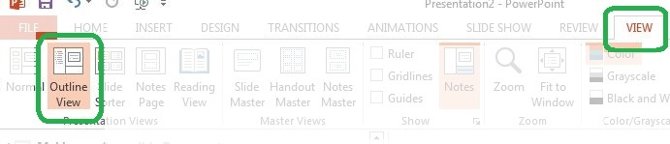
In a panel at the left of the PowerPoint window, you will see the outline of your presentation, slide by slide. If you are creating a new presentation, you will see only one slide—the title slide. Enter the title of the presentation in the first content placeholder. In the second content placeholder, enter all the other information required by your organization.

Use PowerPoint’s Standard Layouts
The title slide is one of nine standard layouts available in the default theme of PowerPoint 2013 & 2016. Most of these layouts are built from content placeholders. When you use these layouts and create your content in a placeholder, screen readers will follow the correct order as they advance through each slide.
To choose a layout for any slide, right-click in a blank area of the slide—in other words, outside of any placeholder. When the context menu opens, click Layout. Then select the layout you need. You may also use this approach to change the layout of any existing slide.
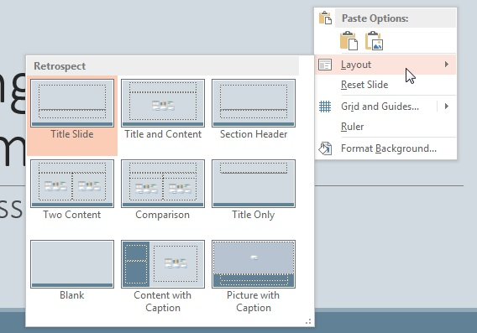

Put a Title on Each Slide
Every layout we recommend has a title placeholder. Use it to give a unique title to each slide. When you do, the title will also appear on that slide in the Outline panel. Because people using screen readers can navigate from slide to slide and the title placeholder is the first thing the screen reader will find in a standard layout, this is almost as powerful as assigning a heading level to the title of the slide. (As we said before, PowerPoint 2013 & 2016 do not have a way to tag actual headings.)
Sometimes a title would add clutter to the slide without offering significant value to people who can see it. If this is the case, make the title of that slide invisible:
- In the Home tab, Drawing group, click Arrange.
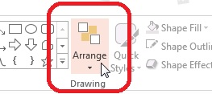
- At the bottom of the dropdown menu, click Selection Pane.
- The Selection Pane will open at the right side of the PowerPoint window. This pane lists each placeholder or object in the current slide’s layout. Title will be at the bottom of the list. Click the icon that looks like an eye to the right of Title. The title will disappear from the slide.
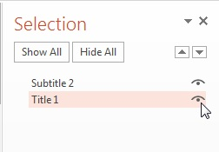
Although you will no longer see the title on the slide, it will remain visible in the Outline. This means that a screen reader will still be able to encounter the title and announce it to the user.

Check the Reading Order of Each Slide
While you have the Selection Pane open, use it to make sure the reading order of each slide is correct. When the order is correct, it seems backwards. The title placeholder is at the bottom, and is read first. The first content placeholder will appear just above the title. It will be read second. The reading order continues up the list until the top placeholder, Slide Number, which is the last content on the slide, is read.
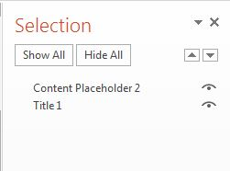
As we said before, the reading order will be correct if you use one of the standard layouts and its content placeholders.
If an item is in the wrong position in the reading order, you may fix it in either of these ways:
- Select the item that is out of place, and then use the Up and Down arrows near the top right of the Selection Pane to move it into the correct location.
- Or click the item, drag it to the correct place, and drop it.
This approach is particularly useful if you have inherited a PowerPoint presentation file that was not built for accessibility.

Use a Standard Layout to Produce Columns of Text
If you put two or more columns of text on a page, use either the Two Content or the Comparison layout for its side-by-side content placeholders. A screen reader can then read the entire first column before reading the second column. This order is easiest for most listeners to follow.
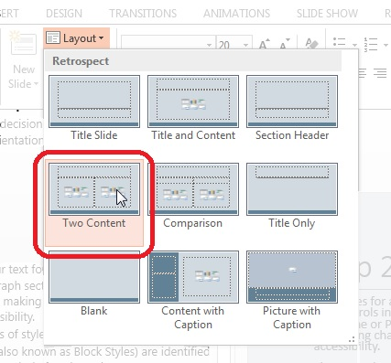
If you want to let the user choose between reading column by column or row by row, use a single placeholder and insert a table to organize the information. See the Tables section of this module for more information.
Never use the Tab key to separate lists of text into columns within a single placeholder.

Keep Other Visual Features Simple and Clear
Two important aspects of accessibility in any presentation are the proper use of color and the use of motion. By “motion,” we mean any content that blinks, flashes, or moves across the screen.

Be Sure Colors Have Enough Contrast
Make sure your text color provides enough contrast with the background color for people to read it easily. Here are a couple of simple rules:
- Always put text on a plain, solid-colored background. Text placed on top of an image or patterned background is harder to see.
- Be sure to provide enough contrast between the text color and the background color. For more information about selecting colors, see the Colors and Contrast module in our Word 2013 & 2016 series.
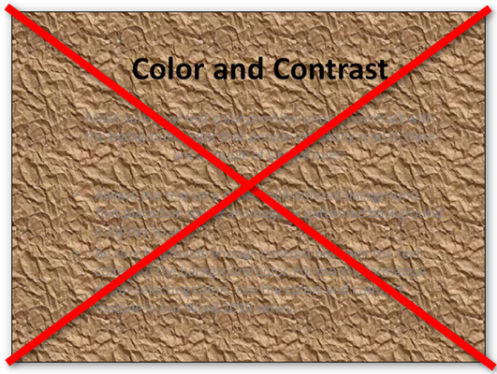

Motion, Blinking, Transitions, and Animations
Content that blinks is a serious issue for accessibility. Content that blinks or flashes more than three times a second can trigger seizures in people with photosensitive epilepsy. Any motion that rapidly changes a region from dark to light and back can be such a trigger. Make sure your presentation is free of these effects.
Animations can be distracting to people with cognitive impairment, sometimes to the point that they will not be able to follow your talk. Use an animation only when it is the best way to show an interaction or process that you need to cover in your talk. You might also use animation to control the appearance of items in a list, allowing one item to appear, discussing it, then allowing the next item to appear, and so on.
Slide transitions are effects used to move from one slide to the next—for example, one slide might slowly fade from view while the next slide slowly appears.
If you use transition and animation effects sparingly, they can enhance your live presentation. Before you distribute the presentation for people to review later, remove those effects. Screen readers do not work well with transitions, and the motion involved can be distracting and confusing to anyone.

Pictures and Other Images
Just as with PDF and Word documents, you must add alt text to images in your PowerPoint slides. This lets people who are using a screen reader know what the images are.
The procedure for adding alt text to an image is similar to that in Word:
- Right-click on the image or the element that encloses it.
- In the context menu, choose Format Picture.
- A Format panel will open. At the top of the panel, click the icon for Size and Properties.
- Choose Alt Text.
- Two fields will display—Title and Description:
  - Leave Title blank. This information is not conveyed to assistive technologies.
  - In Description, enter the alt text.
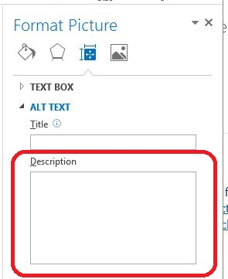
Remember to keep the description short. Decide what you expect people to learn from the picture, and add just enough information to tell them what they need to know.
Also, do not place text over a picture. Many people will be inconvenienced by having to distinguish text from the background image. For people with limited vision, the task might be impossible.

Charts and Graphs
Charts, graphs, and other complex images might contain so much information that it is difficult to sufficiently describe them with alt text. To keep this discussion simple, we will refer to charts when the information applies to all of these situations.
You can approach this problem of complex charts and alt text in two ways:
- First, see if you can simplify the chart, or split it into two or more charts, so that each one contains a smaller amount of information. This will not only make the alt text for each chart simpler, but also make the information more understandable for everyone in your audience.
- If a chart is still too complex to describe with alt text, you will need to provide a text description elsewhere. As we describe in our module on delivering accessible presentations, you can add the full description to the Notes section of the slide. If you do this, put a very short description of the chart in the alt text, ending with the words "Full text description in the Notes section of this slide." If you place that note on the slide itself, even people who do not use screen readers will be able to find the text description.
In addition to the complexities of alt text, graphs in PowerPoint 2013 & 2016 present difficult issues for people with low vision—and for anyone unfortunate enough to be at the back of a large presentation hall:
- The color scheme used in the default Office theme has too little contrast for the lines to be seen easily from a distance. Refer to the module on Colors and Contrast in the Word 2013 & 2016 series.
- Even if you darken the lines, they are too thin to be seen from the back row. Make them thicker.
- If individual data points need to be highlighted, they are too small. Make them larger.
- The fonts for the axes and labels are too small. Make them at least 18 point.
These adjustments will not only help people with low vision understand your electronic file but also help everyone in the room during your live presentation see the graph clearly and understand the information in it.

Tables
Data tables are used to display information in a grid with rows and columns. A header at the top of each column or at the beginning of each row helps the reader understand what type of information they can find.
Whenever you create a data table on a slide, follow these guidelines.
- In a content placeholder in one of the standard layouts, click on the Insert Table option.
- In the ribbon, the Table Tools Design tab opens. As a data table, it must have column headers, row headers, or both. In the Table Style Options group:
  - If your table will have column headers, be sure the Header Row option is checked.
  - If your table will have row headers, be sure the First Column option is checked.
  - If your table will have both column and row headers, check both options.
- Select other design options in the Table Style Options and Table Styles groups to set the text, background, banding patterns, and grid colors for the table. When selecting a style, consider these issues:
  - Be sure there is enough contrast between the text and background colors of each cell.
  - Choose a table style that provides grid lines to separate the data cells. People viewing the slide through a screen magnifier will be able to use the grid lines to follow each row across the page, especially if there is a lot of space between the text in adjacent cells. The grid lines are also useful for separating cells if there is a lot of text.
- Use simple data tables. Never merge two or more cells into a single larger cell or split a cell into smaller cells. The table should be a simple grid with predictable rows and columns. Complex table structure is nearly impossible to follow with a screen reader.
- Don’t leave columns or rows blank. If someone is listening to a screen reader announce the information in the table, they may think the table has ended if they encounter a blank row. If you want to provide more separation between rows, switch to the Table Tools Layout tab and use the Cell Margins control in the Alignment tab to increase the top and bottom margins of each table cell.
Tables in PowerPoint files have proved to be a challenge for screen readers to interpret, but by using these techniques you will produce tables that are as accessible as possible.

SmartArt Graphics
In the content placeholders of PowerPoint 2013 & 2016, one control allows you to insert SmartArt Graphics. SmartArt Graphics are collections of geometric shapes that you can add text to. The overall effect could be to illustrate a process, as with a flowchart, or to show relationships, as with an org chart.
By adding alt text to a SmartArt Graphic, you can make the text in it fully accessible to a person using a screen reader. The process for adding alt text is the same as we described for pictures, but there is a little more to it with a SmartArt Graphic:
- Right-click on the background of the placeholder containing the SmartArt Graphic. In the context menu, choose Format Object.
- In the Format Object panel, click on the Size and Properties icon.
- Choose Alt Text. In the Description, enter the alt text for the overall graphic. For example, if the graphic is a flowchart, the alt text might be, “Flowchart: Reviewing a Job Application.”
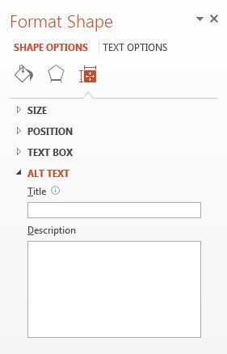
- Click on the first individual shape in the graphic. The Alt Text dialog will remain open, but the title of the panel will change to Format Shape.
- The Description will be blank. Enter the alt text for just that one shape. For example, in our flowchart for reviewing a job application, maybe this shape represents the first step, “Receive Application from Applicant.”
- Continue through the graphic, one shape at a time, until you have entered all the text shown.

Multimedia: Video and Audio
Another of the types of content you can insert into a content placeholder is an audio or video file. If you include multimedia content in your presentation, you will need to make it accessible.
- Video content must have synchronized captions.
- Video content will also need a rich description of the visual components.
- Audio content must have a transcript.
You might find it easier to remove the audio and video from the PowerPoint presentation and provide those elements in different formats. For example, you might host the file online and link to it from the PowerPoint presentation file.

Accessibility Checker
The accessibility checker in PowerPoint 2013 & 2016 can help you find some types of accessibility problems. It will show you a list of errors it finds, along with instructions on how to fix them. Learn more about the checker in the Word 2013 & 2016 training series.
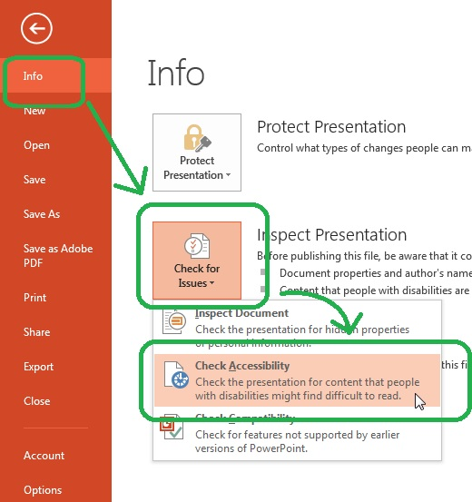

This concludes our PowerPoint module on designing accessible PowerPoint presentations.

