PowerPoint 2010: Accessible Presentations
Contents
PowerPoint 2010: Accessible Presentations 1
Introduction 1
Prepare Your Presentation for Your Expected Audience 1
Handouts 2
The Visual Presentation 2
Making a PowerPoint Presentation Accessible 2
Color and Contrast 2
Layout 3
Columns of Text 4
Reading Order when Multiple Placeholders Are Used 4
Changing the Reading Order 4
Motion, Blinking, Transitions, and Animations 5
Multimedia and Figures 6
Accessibility Checker 6
Conclusion 6

Introduction
In this module, we discuss how to make a live presentation accessible to everyone, including people with disabilities. Then, we cover the requirements for making your PowerPoint slides and presentation handouts accessible.

Prepare Your Presentation for Your Expected Audience
When you are making a live presentation to a group of people, you need to consider who your audience is.
Before your presentation, you should ask if anyone needs an accessibility accommodation. You may learn that there will be an attendee in the room who is deaf or hard of hearing, possibly needing a sign language interpreter. If there will be attendees with low vision, you may need to prepare handouts with large print, or perhaps send an electronic version of the slides to let people follow along on their laptops. If the room is large, you may need a sound system.
During the presentation:
- If there is a question from the audience, clearly repeat the question before answering it.
- Always speak clearly and at a moderate pace, and face the audience while speaking.
These habits help people who are hard of hearing, the sign language interpreter if there is one and everyone else in the audience as well.

Handouts
Make sure your handouts are usable by everyone. If there is someone who is blind or has low vision, offer to send an electronic copy of your handout in advance. You can also consider large-print handouts for attendees with low vision.
After the presentation, members of the audience often want an electronic version of the handouts. Be sure the electronic version follows accessibility rules, so that it can be used by everyone.
PowerPoint works well for creating slides to project during live presentations, but it is less useful for creating accessible handouts. PowerPoint does not provide a heading structure that can be used by screen readers to help users quickly jump to another section. Some of the other elements often used in slides, like data tables, are difficult to understand when listening with a screen reader. Consider creating a Word or PDF document to improve the usability of your handouts.

The Visual Presentation
PowerPoint is designed for creating visual presentation aids. Another option is to create the visual presentation using HTML to create web pages that are viewed in a browser. Since a web browser is standard on nearly every computer, and documents created with HTML are the most accessible type of document, this is a good choice.

Making a PowerPoint Presentation Accessible
If you choose to use PowerPoint, the same general rules you use to make any electronic document accessible apply, with a few techniques specific to PowerPoint.

Color and Contrast
Make sure your text color provides enough contrast with the background color that people can easily read it. Here are a couple of simple rules:
- Always put text on a plain, solid-colored background. Text placed on top of an image or patterned background is harder to see.
- Be sure to provide enough contrast between the text color and the background color. For more information about selecting colors, see the colors and contrast module in our Word 2010 series.
1. Avoid patterned backgrounds.
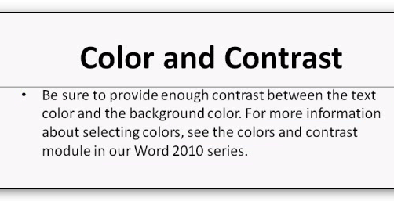
2. Use solid backgrounds and provide contrast.

Layout
Use one of the standard layout templates when you insert a new slide into PowerPoint. These layouts provide boxes, called placeholders, to insert different types of content, such as the slide title, text, and pictures. Placeholders come preformatted for a range of purposes and help ensure that each slide is as accessible as possible for people using screen readers.
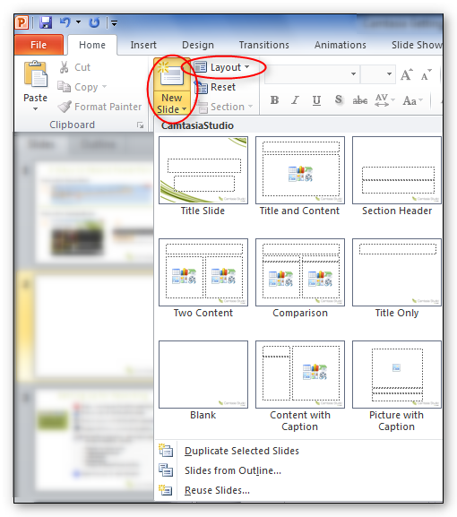
3. Choose a layout.

Columns of Text
If you put two or more columns of text on a page, use a standard layout that has two side-by-side text box placeholders. Never use the Tab key to separate lists of text into columns within a single text box. By using text box placeholders, a screen reader will read the entire first text box, and then move to the next text box in the slide's reading order. This will make much more sense to the listener.
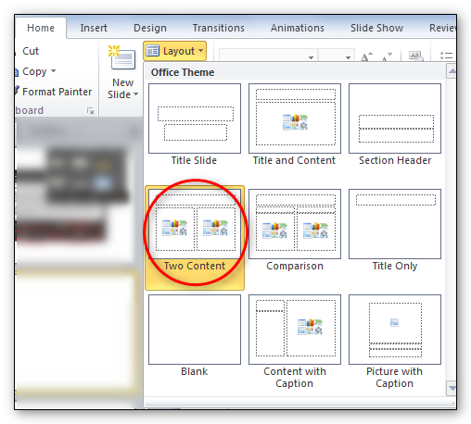
4. Use a layout for columns. Don't use tabs.

Reading Order when Multiple Placeholders Are Used
If there is more than one placeholder on a slide, how do you know the order a screen reader will read the page?
There is a quick way to learn the reading order using the Tab key.
- Press the Page Down key to go to the page you want to check.
- Press the Tab key. A box appears around one of the placeholders indicating the keyboard focus. A screen reader reads the text in this box first.
- Press Tab again to see the next placeholder in the reading order. Continue with this until you move through all of the placeholders on the page. This is the same order that the screen reader will read the page.
- When you get to the last element on the page, press Tab again to cycle back to the first element on the page.

Changing the Reading Order
You can change the reading order by using the Bring to Front and Send to Back options for each placeholder on the page.
- Decide what order you want the page to be read.
- Right click on the box that surrounds the first placeholder in the desired reading order and select the Bring to Front option from the context menu.
- Select the NEXT item you want to be read, right click on that placeholder box, and select Bring to Front again.
- Go through all of the placeholders in the order you want the screen reader to announce the page, selecting Bring to Front each time till you get to the last item on the page.
- When you complete the page, repeat the Tab key process to verify that the tab order is correct. Alternately, you can start from the last item on the page and use the Send to Back option, going backwards to the first item on the page.
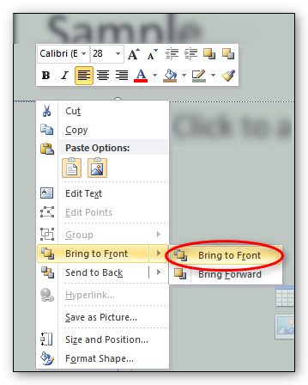
5. Change reading order by right-clicking and choosing Bring to Front for each object.

Motion, Blinking, Transitions, and Animations
A common accessibility issue concerns moving or blinking content. Blinking or flashing elements can cause seizures in some people. Do not use any element that flashes, blinks, or has a repetitive motion that repeats faster than 3 times per second. Even people who are not susceptible to seizures are often distracted by these types of content, so it is better to just avoid them altogether.
Slide transitions are effects used to move from one slide to the next, for example, slowly fading away from one slide while the next slide slowly appears. An example of an animation is when you have bullet points appear one at a time on a page, until the entire slide is displayed.
If used sparingly, transition and animation effects can be useful during a live presentation. However, they should be removed if you distribute the presentation as a resource for people to review after the presentation. Screen readers do not work well with transitions, and they can be distracting and confusing for people who are reviewing the presentation.

Multimedia and Figures
If you include multimedia content, such as audio or video, in your presentation, you will need to make it accessible.
- Video content must have synchronized captions.
- Audio content must have a transcript.
- You may find it easier to remove the audio and video from the PowerPoint presentation and provide those elements in different formats.
Some elements, such as images, tables, charts, and shapes, have specific techniques to make them more accessible. Another PowerPoint module in this series will go into more detail on those topics.

Accessibility Checker
The accessibility checker in PowerPoint 2010 can help you find some types of accessibility problems. It will show you a list of errors it finds, along with instructions on how to fix them. Learn more about the checker in the Word 2010 training series.
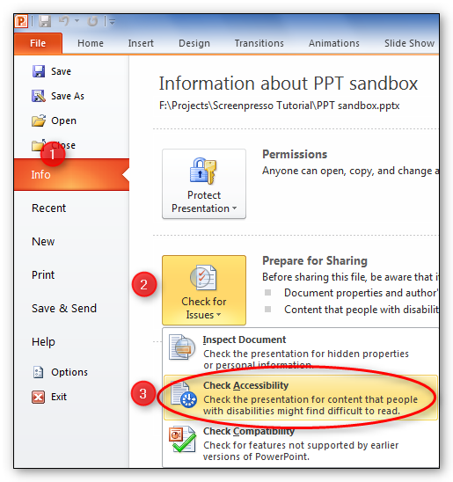
7. Use the Accessibility Checker.

Conclusion
In this module we discussed some of the accessibility considerations involved with live presentations, and an overview of accessibility issues to consider when creating a PowerPoint document.
You can find more information about creating accessible PowerPoint documents in the next training module, Adding Tables, Charts, Images, and Shapes.

