Excel 2010: Accessible Excel Forms, Part 1
Contents
Excel 2010: Accessible Excel Forms, Part 1 1
Introduction 1
Designing Your Form 1
Steps from Previous Modules 1
Shading the Input Cells for Visual Effect 2
Data Validation 2
Providing Input Messages about Your Form Fields 3
Creating Dropdown Lists of Possible Entries 3
To Summarize 5

Introduction
Forms in Excel help the end user fill out information, and also help the form owner to quickly access that information. While some users will print out forms, our emphasis is on forms that are used electronically. To make an Excel form accessible, we focus on
- Allowing the end user to navigate using the keyboard.
- Providing helpful instructions that are accessible to visually impaired users who employ assistive technology screen readers.
This is the first of two modules about Excel Forms.

Designing Your Form
- Set your form up with descriptive fields and fill-in-the-blank fields, with layout and formatting that is easy for the user to see and understand.
- Remember that the cell that tells how to fill out a form (such as the words, “Street Address”) must be in a separate cell, next to the cell where the users will type in their address.

Steps from Previous Modules
Many steps covered in the Excel Spreadsheets modules are also important for accessible forms. Here are some of the most important ones to keep in mind for your Excel Form:
- Provide clear, meaningful titles.
- Add Help Text in the First Cell, A1.
- Name worksheet tabs and delete unused tabs.
- Avoid empty rows, columns, and cells.
- Label the end of your form.
- Set the print area.
- Hide unused cells.
- Delete or hide unused worksheets.
Review the Excel Spreadsheets Modules for help with these important steps.
Now on to specific information for Excel Forms.

Shading the Input Cells for Visual Effect
Shading the input fields helps the end user by making it easier for people to find the input fields if they are using a mouse and when entering information.
- Move the cursor to one of your input fields.
- In the Home tab of the ribbon, find the Font group and select the small arrow next to the Fill Color button, which has a bucket icon. A Theme Colors gallery appears.
- Choose a color for the background shading of that cell. Choose a light color, since darker background colors make text in the fields harder to read.
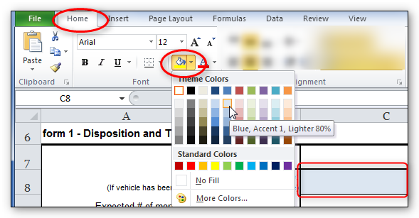
- Move to the next cell and repeat the process, or press Ctrl+Y to repeat the color selection command without having to go back to the ribbon.
- You may also select multiple cells by holding down the Ctrl key while left-clicking each cell. Then you can perform the operation once for many cells.

Data Validation
Data Validation contains many tools that will help create useful forms. Data validation will help to:
- Provide input messages about your form fields.
- Create dropdown lists of possible entries.
- Prevent the wrong kind of data from being entered.
We’ll cover each of these in turn.

Providing Input Messages about Your Form Fields
Let’s say you have a field called Name, but you specifically want the person filling out the form to input the data as Last Name, First Name. You can include those instructions in an input message. Here’s how:
- Select the cell where the user inputs the data.
- In the Ribbon, go to the Data tab. In the Data Tools group, click on Data Validation.
- Click on the Input Message tab.
- Ignore the Title field. Type your instructional text into the Input Message field.
- Be sure that the Show input message when cell is selected checkbox is checked.
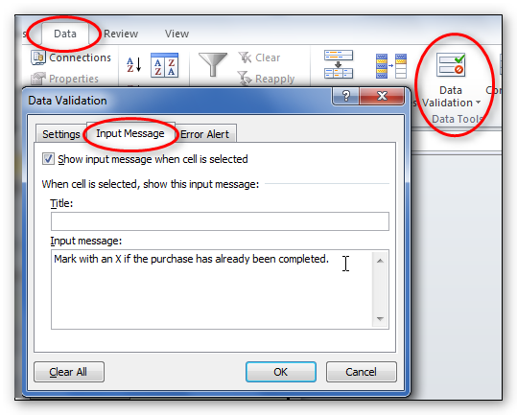
- Choose OK to close the window.
- Now when you click or tab to that cell, the message appears in a floating box.
You can use the same Data Validation Input Message tab to add other information you need your readers to know, information you might typically put in a comment. Since screen readers such as JAWS cannot read Excel comments, we use Data Validation for this purpose as well. An example might be in the cell containing the title of the form. Follow the same steps we just described for input messages.

Creating Dropdown Lists of Possible Entries
You can create a dropdown list for filling out a form field. The user can only select options on that list.
- Select the cell in your form where the user will input the information.
- In the Data ribbon, choose Data Validation. The Data Validation dialog box opens.
- In the Settings tab, in the Allow dropdown box, choose List.
- Uncheck the Ignore Blank checkbox if leaving the field blank is not acceptable. Check the In-cell dropdown checkbox.
- In the Source field, type in the first value, followed by a comma and space, and then type the next value.
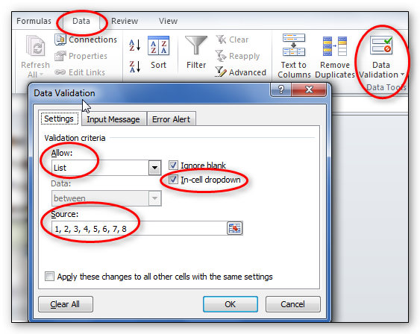
- Continue until the last value is added. Don’t add commas or spaces after the last value.
- Finally, click OK to close the Data Validation dialog box.
Now test the dropdown box.
- Select the cell. You should see the dropdown arrow to the right of the cell. Click that arrow and try choosing a value.
- To open a dropdown list using your keyboard, press Alt+Down Arrow to open the dropdown. Choose a value using the Arrow keys, and then press the Enter key to select it.
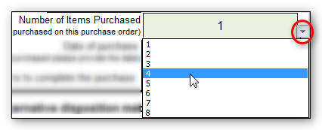
- Finally, when you create a dropdown list in your form, don’t forget to add instructions that explain how to use the list, including keyboard access. Add instructions as explained above, using the Data Validation Input Message.
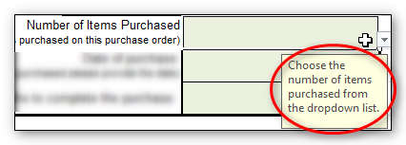

To Summarize
We discussed:
- Designing your form in Excel
- Steps from Previous Modules
- Shading the Input Cells for Visual Effect
- And Data validation, including:
  - Providing Input Messages about Your Form Fields
  - And Creating Dropdown Lists of Possible Entries
If you follow the steps in this module and the next, you’ll have an Excel form that will be easy to understand and will also be accessible to just about anyone, including those using assistive technologies. Remember to review accessibility requirements explained in previous Excel modules. Now please visit Part 2 of the Excel Forms training.

