Excel 2010: Creating an Accessible Excel Spreadsheet, Part 2
Contents
Excel 2010: Creating an Accessible Excel Spreadsheet, Part 2 1
Introduction 1
Further Steps to Assist with Screen Readers in Excel 1
Screen Reader Help Text in Cell A1 1
Table Titles 2
Images 2
Charts 3
Avoid Blank Rows and Columns 3
Merged Cells 3
End of Worksheet 4
Defining the Title Region – a Very Important Step 4
Here’s how to do it: 4
To Summarize 6

Introduction
If you haven’t already viewed Excel 2010: Creating an Accessible Excel Spreadsheet, Part 1, you’ll want to check it out to ensure you’re doing everything you can to make your Excel tables and spreadsheets accessible. In that module we described a lot of good, general practices in Excel that also improve accessibility. In this module, we go further with more tips, most of which are specifically for assistive technology screen readers like JAWS.
Note: for making forms in Excel accessible, see Excel 2010: Creating Accessible Forms Parts 1 and 2 in addition to ensuring your form has covered the accessibility considerations in these two modules for spreadsheets.

Further Steps to Assist with Screen Readers in Excel

Screen Reader Help Text in Cell A1
Provide help text for navigation using screen readers, in cell A1.
- For example, “Press TAB to move to input areas. Press UP or DOWN ARROW in column A to read through the document.”
- You can make this text fairly small, or even change the color to match the background color. This way it will not show up visually, but will still be read by the screen reader.
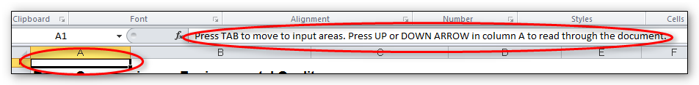

Table Titles
Table titles should be placed in the first column so screen readers can find them easily, as discussed in the previous module.
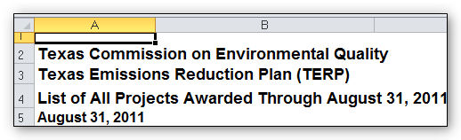
If that looks funny you can merge cells and center them, but keep the original text in the first column.
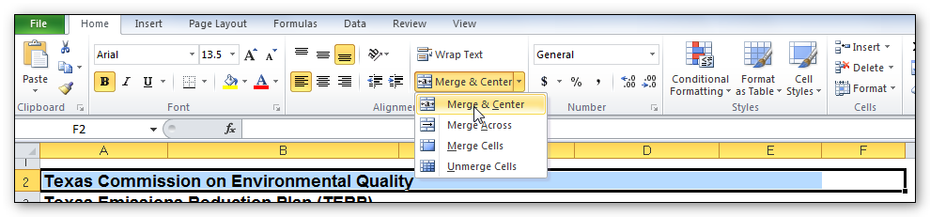

Images
Ensure that any images have alternate text descriptions. Follow the steps below, or use the method for charts that we’ll discuss next.
- Insert the image, then right-click and choose Size and Properties.
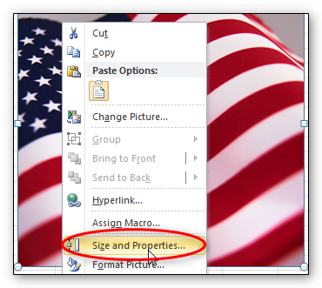
- In the Size and Properties dialog box, choose the Alt Text tab. Type in a brief description with enough detail to explain the pictures. You don’t need to say “image of” or “picture of” because the screen reader alerts the reader that it is an image.
- Click Close.
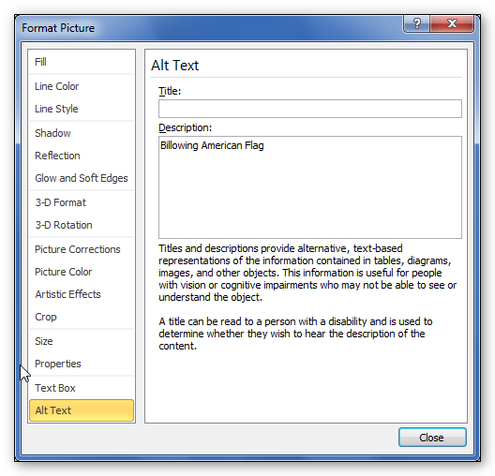

Charts
Ensure that any charts have alternative text descriptions. This is different than images, since charts created in Excel don’t have an area for Alt Text.
- Resize the row where you want to insert the chart. You may merge cells if you want.
- Insert the chart.
- In the cell where the chart is, type the description. This description may need to be fairly long to adequately explain the chart.
- Hide the text of the description by changing the text color to match the background.
- Now when a screen reader comes across the cell containing this chart, it will read the text description.

Avoid Blank Rows and Columns
Avoid blank rows and columns within a table.
- Resize your rows and columns to give the spacing that helps make the table readable rather than using blanks to create your spacing.
- One really common mistake is leaving column A blank (because it makes it look like a margin).
- Also, if you have two or more tables on the same worksheet, leave a single blank row between each table. You can resize the blank row to create a space that is visually appealing.

Merged Cells
- It’s OK to have merged cells in titles but not in the data part of the table.

End of Worksheet
- Type End of Worksheet in the row immediately after the last row of your table.
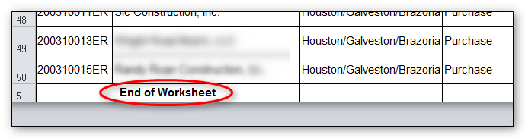

Defining the Title Region – a Very Important Step
One final, advanced step is “defining the Title Region” which is a little bit of code so the screen reader knows to repeat the row and column titles when reading the data. We’ll walk you through that.
First, a little about how a screen reader reads a table: the default for a screen reader in English is to read starting at the top, and going left to right. When it gets to the end of a line, it goes to the next line down and reads, again, from left to right.
Now imagine a screen reader reading this table [example defining title region.xlsx]. Without some help from you, the screen reader reads it like a book. After the title, it will read, “Type, January, February, March, April, etc. Then it will go to the next line and read Sci Fi 4, 3, 3, 2, 5, 6, and so on. As sighted readers, we are constantly referring back to the row and column headers to see what the numbers refer to. Visually impaired users need those references too.
What we need is for the screen reader to read this way:
- Sci Fi: January, 4;
- February, 3;
- March, 3;
- And so on.
In other words, the screen reader should repeat the column header each time before it reads the value. The good news is that screen readers are smart enough to do that! We just have to tell them how our table is set up and how to read it. In our example, we’ll just use a standard table with several columns and several rows.

Here’s how to do it:
- Before we get going, we need to know three things about our table:
  - Is this the first (or only) table on this worksheet?
  - What are the addresses of the top left and bottom right cells in your table?
  - Is this worksheet the first (or only) worksheet in this workbook?
- To get started, select the top-left cell in your table. Don’t count the titles, but you do count all row and column headers as part of your table.
- Go to the Formulas tab in the Ribbon, and choose Name Manager in the Defined Names group. Choose New in the top left corner. A new dialog box opens. In the Name field, we are going to type a fairly complicated name.
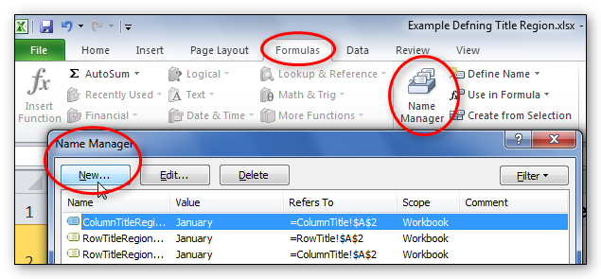
- Type TitleRegion then put a 1 if this is the first table on your worksheet; then a period; then the range of cells in your table from top left to bottom right (with a period in between); then another period; then the worksheet number. So in this case our Title code looks like this:
  - TitleRegion1.a2.g7.2
You can ignore all other fields in this dialog box. Click OK and Close.
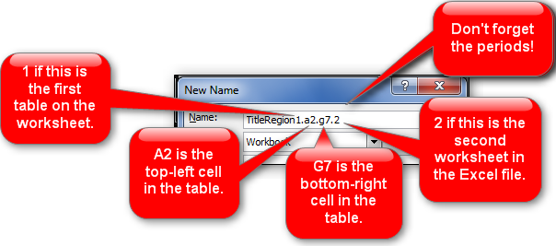
- That’s it! You’ve just given JAWS the instructions for how to properly read the table so the listener can easily understand it.
- By the way, if your table only has one column header, define a ColumnTitleRegion instead of a TitleRegion. If your table only has one row header, define a RowTitleRegion. The rest of the coding is the same.
- Finally, if you create these titles and then make a simple change, such as moving your worksheet tabs around or adding an extra row, you’ll have to recode the titles to match your spreadsheet’s new reality. So save this step for when you are ready to publish.
- If you do need to edit these names, go back to the Name Manager, select the name you wish to edit, and choose the Edit button.

To Summarize
We discussed:
- Providing keystroke navigation instructions at the beginning of your document
- Keeping table titles in the first column
- Providing alternate text for images and charts
- Avoiding blank rows and columns
- Typing “End of Worksheet” at the bottom
- And Defining the Title Region
If you follow the steps in Excel 2010: Creating an Accessible Excel Spreadsheet, Part 1 and this module, you will have an Excel spreadsheet that will be easy to understand and also will be accessible to just about anyone, including those using assistive technologies. If you are creating a form in Excel, be sure to check out the next two modules: Excel 2010: Creating Accessible Forms Parts 1 and 2.

