Excel 2010: Creating an Accessible Excel Spreadsheet, Part 1
Contents
Excel 2010: Creating an Accessible Excel Spreadsheet, Part 1 1
Introduction 2
Common-Sense Practices in Excel that also Help Create Accessible Spreadsheets 2
Contrast 2
Worksheet Names and Table Titles 2
Row and Column Headers 3
No Blank Data Cells 3
Hyperlinks 4
Remove Comments 5
Set Print Area 5
Hide Unused Rows and Columns 5
Delete Unused Worksheets 6
Check Spelling 6
Document Properties 7
To summarize 8

Introduction
To make an Excel spreadsheet accessible, we want to do many things that are good practice anyway, and some specific things for visually impaired users, such as those using assistive technology screen readers. This module focuses on good general Excel practices. The next module, Accessible Excel Spreadsheets Part 2, focuses on specific practices for screen readers.
Note: for making forms in Excel accessible, see Accessible Excel Forms Parts 1 and 2 in addition to ensuring your form has covered the accessibility considerations in these two modules for spreadsheets.

Common-Sense Practices in Excel that also Help Create Accessible Spreadsheets
These practices not only make sense for all spreadsheets, they also help make your spreadsheets more accessible at the same time.

Contrast
Follow contrast guidelines covered in the Word module about Contrast.
The easiest way to do this is just to leave the whole workbook in black and white. If you do use color, refer to the Word module about Contrast for ways to check that there is adequate contrast for all types of readers.

Worksheet Names and Table Titles
Provide descriptive titles in the worksheet name tab and for each table.
- To change the name of a worksheet, double-click on the tab name and type in a new name (to select the worksheet name with keystrokes, use Alt, O, H, R). Worksheet names can only have 31 characters. There are also some characters it will not accept, including backslash and brackets.
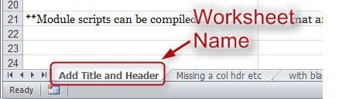

- Give your table a descriptive name that explains what information it contains. For example, instead of the title, “Project Plan,” use a title that will tell the reader five years from now what the table is about, such as, “Office 2010 Accessibility Training Module Timeline, Summer 2012.” It’s fine if the title takes more than one row. It’s also OK if you would like to merge cells to center your title.
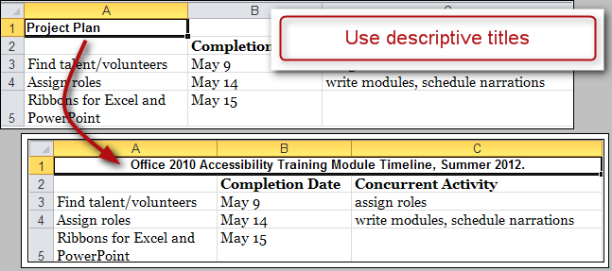

Here’s how to merge cells:
- Start by putting all your titles in the first column (this helps the screen reader find them easily).
- Next, select the cells you want to merge, then right-click and choose Format Cells. The Format Cells dialog box opens up.
- Then, choose the Alignment tab, and check the Merge cells box.
- Finally, in the Horizontal text alignment box, choose Center (assuming you want your title centered), then choose OK.

Row and Column Headers
Each table should have row and column headers for every column and every row in a way that makes sense. Don’t leave any headers blank, even if the meaning seems obvious to you.
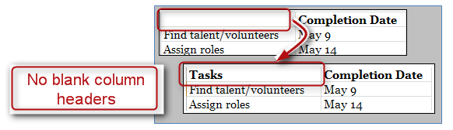

No Blank Data Cells
Cells should not be left blank either. If the cell really has no data, then you can put in: “This cell intentionally left blank” or “No data.” This could be in normal text, or change the text color to match the background so only screen readers will read it.

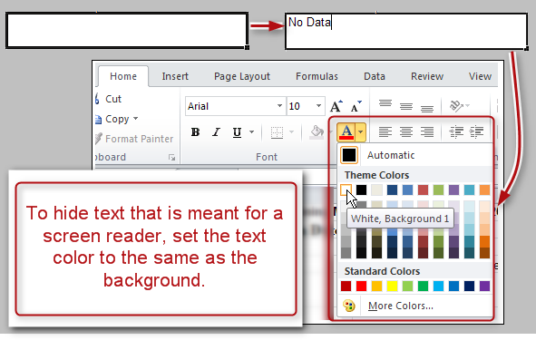

Hyperlinks
Ensure that all hyperlinks work and also show a working URL.
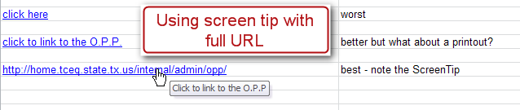
To access the Hyperlink dialog box, Right-Click on the cell and choose Hyperlink (if there isn’t a hyperlink yet) or Edit Hyperlink (if there is already a hyperlink in that cell).
- Avoid hyperlinks that say ‘click here.’ Your link should include the web address itself. Think about someone printing out your table. Will they be able to access the link? Go ahead and include everything, including http://.
- Add a ScreenTip. ScreenTips provide additional information about the link, and are readable by screen readers.
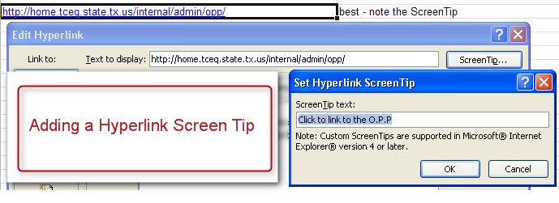
Here’s how to add a ScreenTip:
  - Right-click on the cell where your URL is located, and choose Edit Hyperlink.
  - In the Hyperlinks dialog box, choose the ScreenTip button at the top right. In the new box, type in a meaningful explanation of where the link will take the reader.
  - Click OK twice to close both dialog boxes.

Remove Comments
Remove extraneous comments before publishing (such as those you used when peer-reviewing). Screen readers can’t read these, so if that information is important to your audience, copy it out of the comments and put it in a cell.
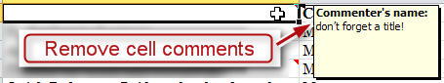
We’ll discuss another “pop-up” alternative to comments in the Excel Forms module. To remove a comment, select the cell containing the comment. Right-click, and choose Delete Comment. Using the keyboard, when focus is in a cell that contains a comment you can press Alt, R, D to delete the comment.

Set Print Area
Ensure the print area is set correctly.
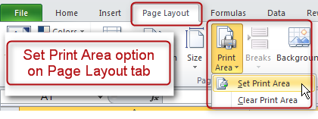
- Highlight the entire area of the table including titles and other information
- In the Ribbon, select the Page Layout tab.
- In the Page Setup group, select Print Area, and Set Print Area.

Hide Unused Rows and Columns
Hide extra rows and columns that are outside the print area. This makes the worksheet look less cluttered and prevents screen reader-users and keyboard navigators from wasting time wandering off into a trackless waste of blank cells.

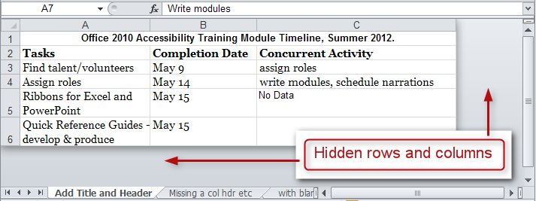
To hide columns:
- To begin, select the first column you want to hide. Now, while holding down the Shift key, press and release the End key on your keyboard. Still holding down the Shift, now choose the right arrow key. This selects all columns from the first one you selected all the way to the right end of the spreadsheet.
- Now, with your cursor hovering in the selected area, right-click and choose Hide.
- To hide columns using the keyboard, select the columns you wish to hide and press Control+0 (zero).
To hide rows:
- To hide unused rows below your data, follow a similar procedure. Leave one blank row below your data, then select the first row you want to hide. Hold Shift as you press and release End and then press and release the down arrow key. Right-click and choose Hide.
- To hide rows using the keyboard, highlight the rows you wish to hide and press Control+9.
If you need to unhide these cells later follow these steps:
- First, select the last visible column.
- Next, hover just to the right of the right edge of the column header. Your cursor should turn from a single cursor with arrows into a double cursor with arrows. Click and drag to the right, exposing the very last column.
- Now select the new, final column, and right-click and choose Unhide.

Delete Unused Worksheets
Delete unused worksheets. Right-click on the tab of the unused worksheet and choose Delete. Using the keyboard, press Alt, H, D, S.
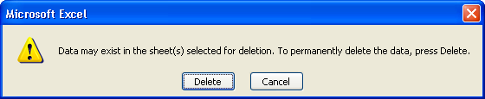
Confirm by selecting Delete in the dialog box that pops up. Be careful, because this cannot be undone.

Check Spelling
Be sure to do a spell-check. Unlike Word, Excel doesn’t automatically put a squiggly red line under any word it thinks is misspelled.
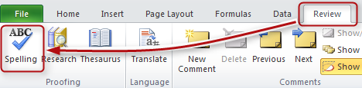
- In the Review tab, choose Spelling in the Proofing group. Follow the prompts.
- Also, Excel will only spell-check one worksheet at a time, not the whole workbook.

Document Properties
Fill out the Document Properties to assist all people in finding your document if it gets put on a website.
Click the File tab, and choose the Info tab seen on the left. On the right side there is a frame containing the properties. You may insert your properties directly here, or access the traditional document properties by clicking the word Properties and choosing Show Document Panel. Either way works.
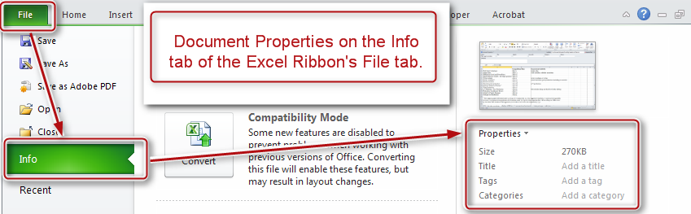
Here is a screenshot of the document panel:
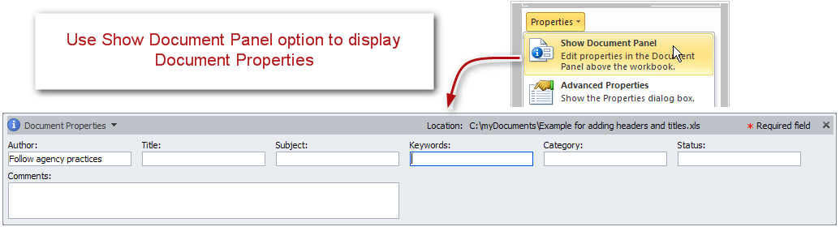
When completing the document panel:
- For author, follow your agency’s practices. For external publication, some agencies suggest putting the agency name instead of the person’s name.
- Choose keywords that fit the subject matter, such as the name of your division and the year.
- Whatever you put as the subject should probably also be in the keywords or tags.
- In status, you might put Draft or Final. Don’t forget to change that if the status changes!
- Close the document properties by clicking on the X in the top right corner.
- Don’t forget to save your document!

To summarize
We discussed:
- Using proper contrast
- Providing descriptive title
- Ensuring you have row and column headers for your table
- Not leaving unnecessary blank cells
- Best practices for hyperlinks
- Getting rid of comments
- Setting the Print Area
- Hiding extra Rows and Columns
- Deleting unused worksheets
- Performing a spell check
- And filling out the Document Properties
If you follow these steps you’ve made a good start toward an Excel spreadsheet that will be easy to understand and will also be accessible to just about anyone, including those using assistive technologies. To take it all the way, continue with the additional Excel modules.

