Word 2010: Creating Accessible Word Forms
Contents
Word 2010: Creating Accessible Word Forms 1
Introduction 1
Form Specifications 2
File Type 2
Zoom Level 2
Form Margins 2
Table Layout 2
Borders 4
Row Height 5
Headers 5
Top Row 5
Section Headings 6
Footer 6
Creating Form Inputs 7
Legacy Form Tools 7
Help Text 8
Form Prompts 9
Protecting the Form 10
Summary 10

Introduction
This module covers how to create accessible forms in Microsoft Word. The general strategy is to use a table layout, and populate the form with text inputs from the Legacy Form Tools. Add help text to the form field inputs, and lock the form to allow the user to tab through the inputs. This method consistently works with all tested assistive technologies. We offer a more detailed explanation.
A cautionary note to those who frequently create forms using Word:
- Form fields created using ActiveX Controls and Content Controls do not work properly with current assistive technology.
- ZoomText does not always track Word checkboxes.
- Forms with columns do not tab properly in a protected form.
- Radio buttons or other form elements may not work correctly with various assistive technologies.

Form Specifications

File Type
For a Word form template, use the “.dotx” extension. Otherwise use “.doc” or “.docx”.

Zoom Level
Set the magnification level to at least 100% to accommodate low-vision users. Microsoft Word opens to this by default.
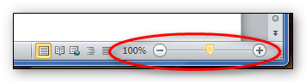

Form Margins
From the Page Layout Tab, go to Page Setup, and select Margins or Custom Margins. Adjust Header and Footer margins if necessary.
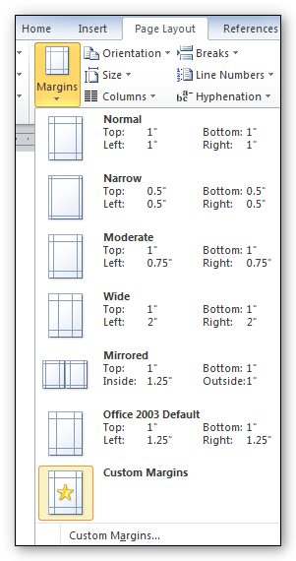

Table Layout
From Insert, select Table, and then choose Insert Table and select the row and column dimensions of the table you want. The table width can be adjusted in Table Properties.
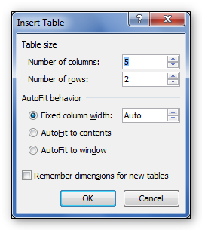
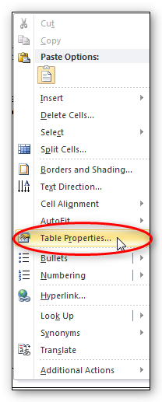

Borders
Use borders to distinguish rows. With a table or cell selected, go to the Table Tools area of the Ribbon, choose the Design tab and click on Borders.
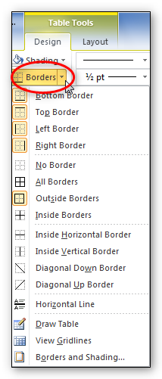

Row Height
In Table Properties, select the Row tab. Set Height to at least, to allow for row expansion when responses are entered.
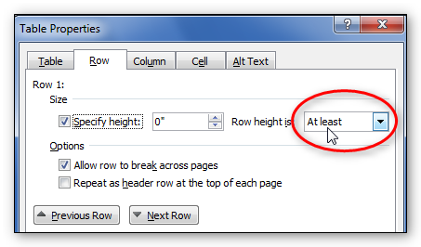

Headers
Do not use page headers. It is difficult for screen-readers to read the content. When necessary, you may use repeating table headers.
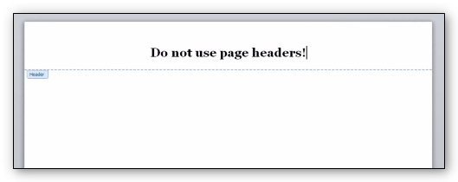

Top Row
Use a top row for logo, form title, or date. Add a form text field to include this information.
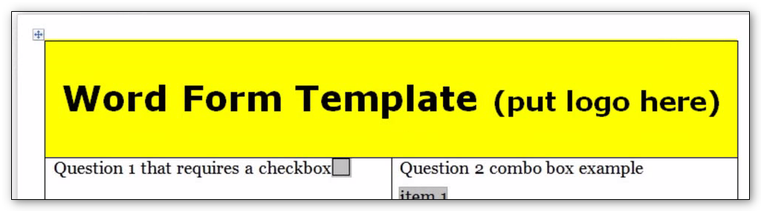

Section Headings
Use section headings to change subject content and to help a low-vision user quickly find a particular section. When creating a section heading row, use:
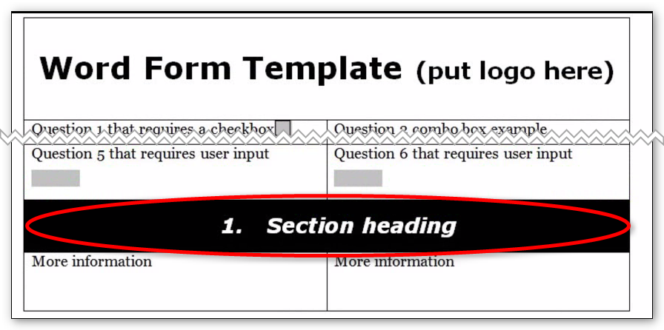
- A single row.
- Black shading, dark borders, or another method to indicate that the row contains a header. This helps low-vision users identify the beginning and end sections of the form.
- Bold text that contrasts with the row shading. For example, if you have black shading, use white text.
- Arabic numbers for easier navigation. Avoid Roman numerals.

Footer
Footer content and design should be specified in your agency’s style guide. For example, the footer could include a form number, publication date, title, and page number.
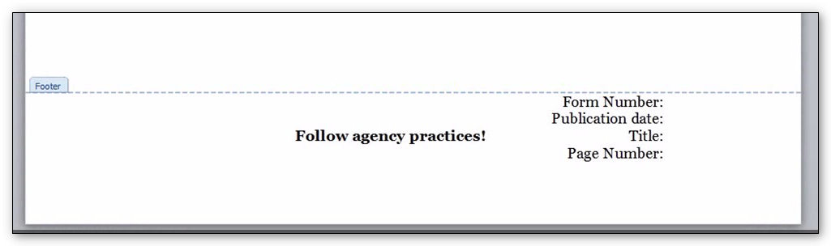

Creating Form Inputs

Legacy Form Tools
The Legacy Form Tools, located on the Productivity or Accessibility tab, are used to create the Text Form Field. Enter data in the Status Bar, which is limited to 128 characters or less. Otherwise, you can use the Help Key or F1 edit boxes, which contain up to 256 characters.
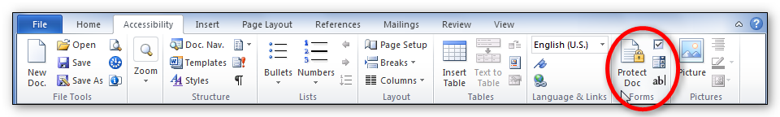
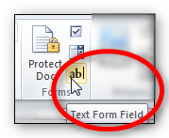
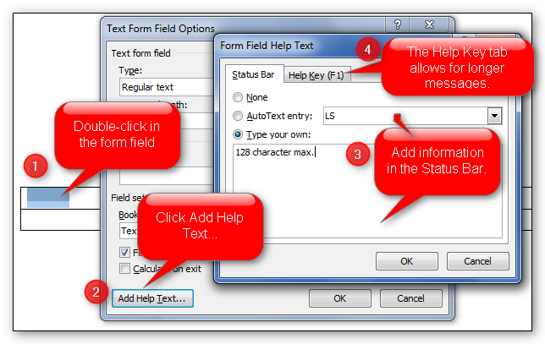

Help Text
Informational text is used to convey information, instructions, or questions related to form prompts to users. The screen-reader software only reads text from the form field prompts within locked sections of a form. To create inputs that provide informational text, set the input size to one character, and preface the help text with “Info.”
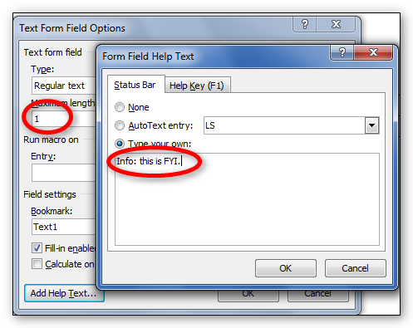

Form Prompts
Form prompts let users know what information to enter. They should match the visual wording of the form.
If the prompt is too long to fit in the Status bar or F1, edit the prompt but maintain the meaning.
Acceptable methods for shortening input text include:
- Substituting symbols for words.
- Using Arabic numbers instead of written numbers.
- Shortening words with contractions.
- Using acronyms or abbreviations (use spaces between letters).

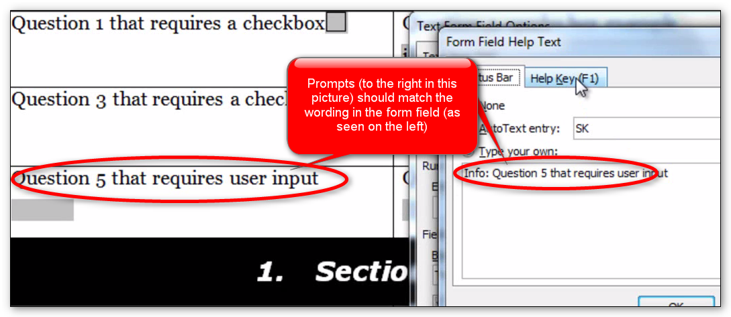
The last form field prompt should contain the words “end of form” to let users know they have reached the end of the form. Otherwise, after completing the final input, and pressing the tab key, they are returned to the top of the form.

Protecting the Form
When you have completed the form, lock the document to protect it. From the Productivity Ribbon, select Protect Document. Next, click the boxes “Allow only this type of editing in the document” and then “filling in form.” From Start enforcement, click “Yes, Start Enforcing Protection.” Finally, close and save the form.

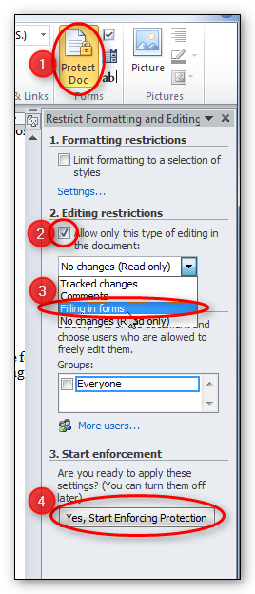

Summary
This concludes our module on creating accessible Word forms. We’ve discussed creating the form from a table, and the specifications of forms, including borders and row height. We also discussed creating form inputs, including adding help text and prompts. Finally, we discussed protecting the form.

