Creating Accessible Documents in Microsoft Word 2013 & 2016: Word Forms
Contents
Creating Accessible Documents in Microsoft Word 2013 & 2016: Word Forms 1
Introduction 1
Parts of a Form 1
Edit Boxes 1
Check Boxes 3
Drop Down (Combo) Boxes 4
Adding Help Key (F1) Help 5
Title, Instructions, and other form content that should be spoken. 6
Form Prompts 7
Protecting the Form 7

Introduction
This module covers how to create accessible forms in Microsoft Word. The general strategy is to create and populate the form with text inputs from the Legacy Form Tools, add help text to the form field inputs, and lock the form to allow the user to tab through the inputs. We offer a more detailed explanation later.

Parts of a Form

Edit Boxes
An edit box is the space a person filling out the form uses to type in text or a response to a question. Usually, a highlighted or shaded area provides a visual marker to show where to fill in this text.
- Place the cursor at the beginning of the space where you expect a person to start filling in text. In the Productivity tab click Text Form Field, also labeled as Edit Box in the Forms group.
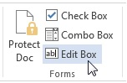
- Right click on the shaded Edit box.
- Choose Properties from the context menu.
- Click into the Bookmark edit box. It should read Text1. Rename this to the same name as the form field label, using mixed case (also called CamelCase) if necessary. Spaces are not allowed in bookmarks in Word.
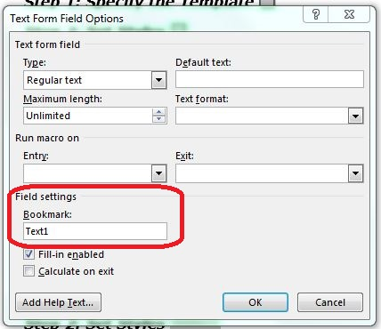
- Activate the Add Help Text button. This brings up a multipage dialog box that allows you to add a meaningful prompt for the person filling out the form.
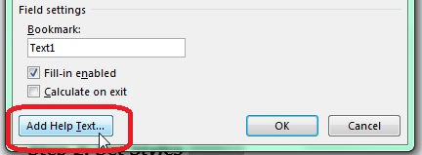
- Click in the edit area for adding your own text. The text you enter here is visible on the Word status bar and is also spoken aloud to a person using JAWS when filling out the form. The field, however, is limited to 138 characters. If the question on the form includes abbreviations such as DOB, spell out the abbreviations (for example, date of birth or put spaces between the letters: D O B) so that the prompt is meaningful.
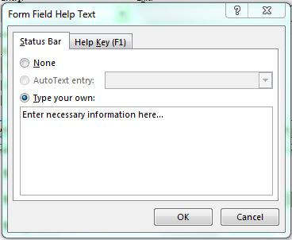
- Click the OK until you have exited all menus and dialogs.

Check Boxes
A check box is a small box generally to the left of a choice, but may be to the right. When the check box is checked (with a mouse or a spacebar) a checkmark or X appears in the box.
- Place the cursor at the beginning of the space where you expect a person filling out the form to place a checkmark.
- In the Productivity Tab choose Check Box Form Field from the forms group.
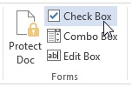
- Right click on the small shaded checkbox in your document.
- Choose Properties from the context menu.
- Click in the Bookmark edit box. It should read Check1. Rename this to the same name as the form field label, using mixed case if necessary.
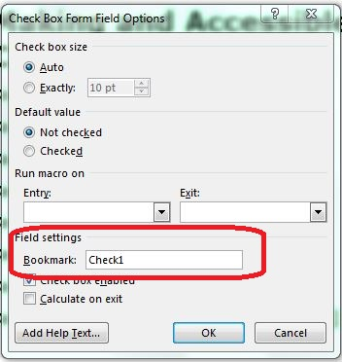
- Activate the Add Help Text button. This brings up a multipage dialog box that allows you to add a meaningful prompt for a person filling out the form.
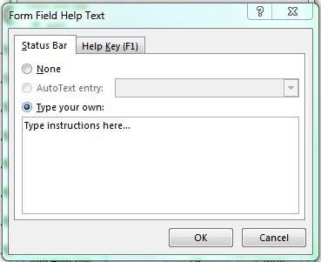
- Click in the edit area to add your own text. In most cases, simply type the same question that is printed on the form.
- Click OK until you have exited all menus and dialogs.

Drop Down (Combo) Boxes
A Drop Down box appears as a rectangular edit box with a graphic of a down arrow appearing to the right of the edit box. This arrow indicates more choices are contained within an attached list box.
- Place the cursor where you want to place the Drop Down List.
- In the Productivity Tab choose Drop Down Form Field from the forms section.
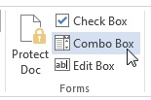
- Right click on the shaded Edit box in the form.
- Choose Properties from the context menu.
- The Drop Down Form Field Options dialog box opens.
- In the Drop down item: edit box type in the first value you wish to use in the list (i.e. Fall).
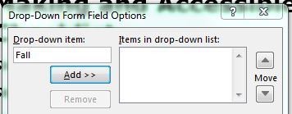
- Click the Add button. The first item is added to the Items in drop down list: on the right, and focus returns to the edit field where you can type in a second value (i.e. Spring).
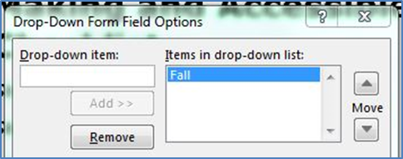
- Continue this process until all of the values you want are added. If needed, you can click on an item in the Items in drop down list: and move that item up or down in the list by using the up or down controls that follow the list.
**Note: The first item in the list becomes the default value. If when the form is used the first answer will be selected even if the user does nothing – in general, use “Pick one” as the first item, then you will know if the user chose not to complete this item.
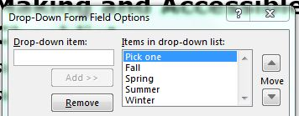
- Click in the Bookmark edit box, and enter the appropriate text.
- Click the Add Help Text button.
- Click in the Type your own: edit field.
- Enter the appropriate text, something short, but that also makes sense.
- Click the OK until you have exited all menus and dialogs.

Adding Help Key (F1) Help
When a JAWS user moves to a control they first hear Status Bar help if it is present (this is the information you entered in the Add Help Text.) This is followed by the message “has F1 Key help,” if it is present. This field is limited to 254 characters.
Use this ONLY if the Help Text prompt is not clear by itself.
When you access the properties of each form control, the Field Options dialog box for the control opens. This is a multipage dialog box.
- Click the Help Key (F1) tab.
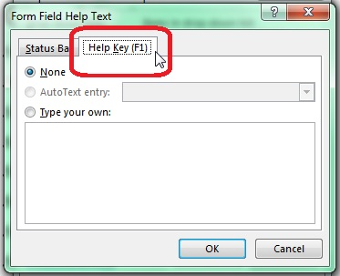
- Click in the edit box and insert the additional text. This field is limited to 254 characters.

Title, Instructions, and other form content that should be spoken.
Forms have title, instructions, and revision dates. Sometimes long forms have different sections with unique set of directions. To allow the JAWS user to hear the instructions.
- At the END of the instructions in the form, insert a checkbox.
- In the Productivity Tab choose Check Box Form Field from the Forms section.
- Right-click on the small shaded checkbox in your document.
- Choose properties from the context menu.
- In the Checkbox Size: click on Exactly: and choose 1pt. This will make the box almost invisible to non-screen reader users.
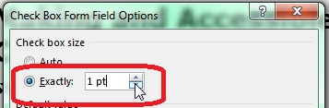
- Click in the Bookmark edit box. Type “Instruction1”.
- Activate the Add Help Text button. This brings up a multipage dialog box that allows you to add a meaningful prompt for the person filling out the form.
- In the help text area start the help text with “info.” (no quotes). Copy and paste (or reword) the instructions. If they will not fit in 128 characters, stop at the end of a sentence or some other appropriate place.
- If the instructions are not yet complete, add another checkbox and more instructions. Remember to start the help text with Info. Repeat as many times as necessary. Remember to update the Bookmark edit box to say Instructions2 or 3 or depending on which it is.

Form Prompts
Form prompts let users know what information to enter. They should match the visual wording of the form.
If the prompt is too long to fit in the Status bar or F1, edit the prompt, but maintain the meaning.
Acceptable methods for shortening input text include:
- Substituting symbols for words.
- Using Arabic numbers instead of written numbers.
- Shortening words with contractions.
- Using acronyms or abbreviations (use spaces between letters).
The last form field prompt should contain the words “end of form” to let users know they have reached the end of the form. Otherwise, after completing the final input, and pressing the tab key, they are returned to the top of the form.

Protecting the Form
When you have completed the form, lock the document to protect it. From the Productivity Tab, select Protect Document. Next, click the boxes “Allow only this type of editing in the document” and then “filling in form.” From Start enforcement, click “Yes, Start Enforcing Protection.” Finally, close and save the form.
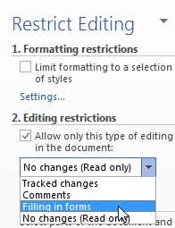
To Disable Protection:
- In the Productivity Tab choose PROTECT DOC from the Forms section.
- The Protect Document dialog will appear on the right side of the window. Click the “Stop Protection” button.
This concludes our module on accessible documents.

