Word 2010: How to Make Accessible Tables
Contents
Word 2010: How to Make Accessible Tables 1
The Good Tables and the Bad 1
Setting the Table 1
Mind Your Table Manners 1
Things You Should Do 1
Things You Should Not Do 3
Using Word’s Accessibility Checker 3
Leftovers 3

The Good Tables and the Bad
Tables can be great for presenting data, but we need to avoid using tables simply to format other content. With earlier word processors, it was common to create entire document layouts with tables. But now we know that using tables for layout—for example, just to line things up neatly—makes it nearly impossible for people who use assistive technologies to access our information. With the techniques described in our other Office 2010 modules, such as applying structure by using styles and using features like the columns tool, we format our documents nicely and make them accessible to everyone, including people with disabilities.
To create accessible tables for the presentation of data, we need to keep them simple and follow a few simple procedures.

Setting the Table
Let’s say you have some data to present and decide to use a table. Where do you begin?
Before you insert your table, it’s a good idea to know how many columns and rows you need. Remember to allow a row for the column headers.
The width of your columns should also be given some consideration, so that the table does not exceed the width of the page. For some tables you may need to change the page orientation to Landscape to give yourself more room horizontally.

Mind Your Table Manners

Things You Should Do
Here’s what you should do when making your accessible table:
- Create your table with the Insert Table tool in the Productivity or Accessibility Ribbon.
Now you will do four things: give your table a title, identify the header row, restrict the table to the page width, and bookmark the table.
- Give your table a title using the Caption tool. Make sure the label field indicates that this is a caption for a table.
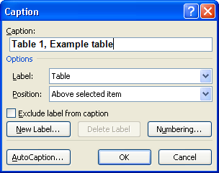
- Identify the header row. Here’s how:
  - First, select just the top row of your table, right click, and choose Table Properties.
  - Next, select the Row tab.
  - Finally, check the box labeled “Repeat as header row at the top of each page”.
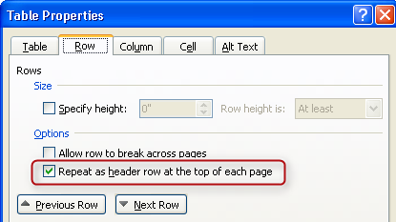
- Restrict the table cells to a single page. To do this:
  - Select the entire table, then right click, and choose Table Properties.
  - Then, select the Row tab.
  - Finally, uncheck the box labeled “Allow rows to break across pages.” Be sure there are no marks inside the box.
- Insert a Bookmark in the first cell of the table:
  - Place your cursor inside the first cell (A1).
  - Then, from the Productivity or Accessibility Tab, click Bookmark.
  - Enter a bookmark name, beginning with “Title”, and then some brief, descriptive text. However, there can be no spaces. Underscores and hyphens are OK. An example is: Title_Salaries_2012.

Things You Should Not Do
And now for what you should not do:
- Do not create your table using the Draw Table tool, which is available only with the Table tools on the Insert ribbon.
- Do not create page layouts with tables.
- Do not merge cells, and do not split cells.
- Do not control spacing in your table with blank rows or columns. Adjust line spacing instead.

Using Word’s Accessibility Checker
The Accessibility Checker in Word 2010 will check your tables if your document was created using Word 2010. If your document was created with a different version of Word, refer to the module “Using the Accessibility Checker” for instructions on converting your document to Word 2010 format.

Leftovers
This concludes our module on How to Make Accessible Tables.

