Word 2010: Colors and Contrast
Contents
Word 2010: Colors and Contrast 1
Introduction 1
Rule 1: Do not ask your reader to make a choice based on color alone 1
Rule 2: Use sufficient contrast 2
Conclusion 2
Resources: 2

Introduction
Appropriate colors and contrast are necessary for people to see our words and understand their meaning. This is especially true for people who are colorblind or have other visual disabilities.
We create documents to communicate. We invest our time organizing our thoughts and carefully choosing our words so we can deliver a clear, concise message. If we then put it all down in a way people cannot read or understand, we have not done our best at communicating.
There are two very simple rules when it comes to color and contrast in our documents:

Rule 1: Do not ask your reader to make a choice based on color alone
Did you know that an estimated eight percent of the population is colorblind? If color is used as the only visual means of conveying a message, asking for a response, or identifying a visual element, then what is a person who is colorblind to do?
Let’s suppose for a moment that you are asking your reader to make a choice based on color. Your closing line may go something like, “If you want to generously donate your next paycheck to my favorite charity, sign in the green box. If you prefer to donate the five dollar minimum, sign in the red box.”
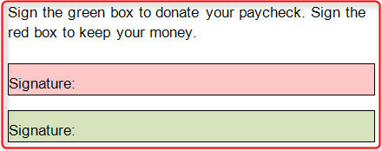
Where should the colorblind reader sign? Most likely, they won’t sign at all.
If you do choose to add color or shading to your document, make sure that the information conveyed in color is also available without color. In the prior example, you might add the appropriate text to the two boxes just to be sure the message is clear.

Rule 2: Use sufficient contrast
A recent design trend involves presenting grey text in small, sans serif fonts on a white background. People with visual disabilities, including those with aging eyes, cannot read this. In fact, even people with perfectly good eyesight have some problems with this.
In most cases, it is enough to say we must use sufficiently contrasting foreground and background colors. But, for those who want a more exacting definition, here is some help.
Text should have a minimum contrast ratio of 4.5 to 1. This is the minimum ratio, not the recommended one.
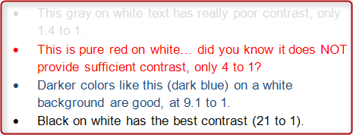
The algorithms used to determine color ratios are far beyond the scope of this module, but there are some excellent online resources to help make good contrast determinations. These tools are designed as guides for Web developers, but the information is equally useful for Word documents. To name a few:
- Snook Color Contrast Check is one of the best for use with Word. Snook’s analyzer allows the user to try various color combinations by moving a series of sliders. The foreground and background combinations are visible and the results are displayed in a table that rates the compliance levels with different font sizes.
- MSF&W Contrast Ratio Calculator is a very good resource. It demonstrates contrast ratios and gives examples of color combinations.
- Color Oracle is a colorblindness simulator. It shows what people with common color vision impairments will see and is available as a free download for Windows or Mac.

Conclusion
To summarize the take-away lessons of this module:
- Never rely on color alone to convey information or meaning, and
- Use sufficiently contrasting foreground and background colors.
The online resources mentioned earlier are listed in the Resources section of this module.
This concludes our module on colors and contrast.

Resources:
- Snook Color Contrast Check
http://www.snook.ca/technical/colour_contrast/colour.html
- MSF&W Contrast Ratio Calculator
http://www.msfw.com/accessibility/tools/contrastratiocalculator.aspx
- Color Oracle
http://colororacle.org/
This requires that you download a zip file, but you may need appropriate permissions or assistance to download and install it.
- Accessibility Color Wheel
http://gmazzocato.altervista.org/colorwheel/wheel.php
- Vision Australia
http://www.visionaustralia.org.au/info.aspx?page=628
This is a free downloadable application. This is one of the best resources we've seen, but you may need appropriate permissions or assistance to download and install it.

