Word 2013 & 2016: Colors and Contrast
Contents
Word 2013 & 2016: Colors and Contrast 1
Introduction 1
Rule 1: Do not ask your reader to make a choice based on color alone 1
Rule 2: Use sufficient contrast 2
Conclusion 2
Resources: 3

Introduction
Appropriate colors and contrast are necessary for people to see our words and understand their meaning. This is especially true for people who are colorblind or have other visual disabilities.
We create documents to communicate. We invest our time organizing our thoughts and carefully choosing our words so we can deliver a clear, concise message. If we then put it all down in a way people cannot read or understand, we have not done our best at communicating.
There are two very simple rules when it comes to color and contrast in our documents:

Rule 1: Do not ask your reader to make a choice based on color alone
Did you know that an estimated eight percent of the population is colorblind? If color is used as the only visual means of conveying a message, asking for a response, or identifying a visual element, then what is a person who is colorblind to do?
Let’s suppose for a moment that you are asking your reader to make a choice based on color. Your closing line may go something like, “If you want to generously donate your next paycheck to my favorite charity, sign in the green box. If you prefer to donate the five dollar minimum, sign in the red box.”
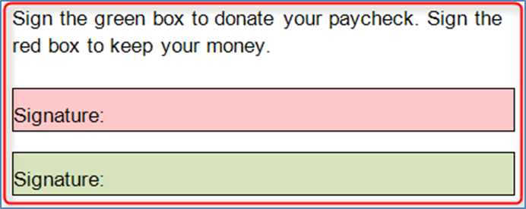
Where should the colorblind reader sign? Most likely, they won’t sign at all.
If you do choose to add color or shading to your document, make sure that the information conveyed in color is also available without color. In the prior example, you might add the appropriate text to the two boxes just to be sure the message is clear.

Rule 2: Use sufficient contrast
A recent design trend involves presenting grey text in small, sans serif fonts on a white background. People with visual disabilities, including those with aging eyes, cannot read this. In fact, even people with perfectly good eyesight have some problems with this.
In most cases, it is enough to say we must use sufficiently contrasting foreground and background colors. But, for those who want a more exacting definition, here is some help.
Text should have a minimum contrast ratio of 4.5 to 1. This is the minimum ratio, not the recommended one. It’s recommended that you have at least a 9.1 to 1 ratio, as seen below.
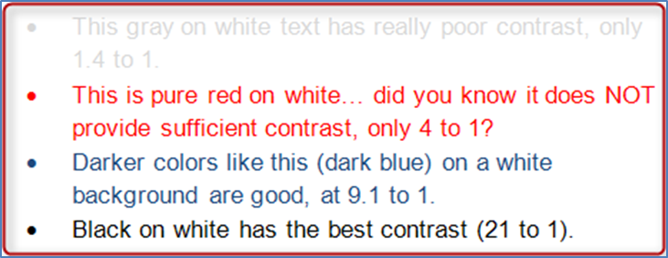
Word and other Microsoft Office programs define colors using a system called RGB, which stands for red, green, and blue. To determine the RGB value of text, select the drop down selector for font color, then select More Colors, then go to the Custom Tab.
Although the algorithms used to determine color ratios are far beyond the scope of this module, there are some excellent online resources to help make good contrast determinations. However, these tools use a different color definition system for Web developers called hex. Fortunately, there are many online tools that convert RGB to hex (try using a web search engine for the term “Convert RGB to hex”). By converting RGB to hex, the tools below can be used by Word users as well. To name a few:
- RGB to Hex is one of many online tools you can use to convert RGB color values to hex color values
- MSF&W Contrast Ratio Calculator is a very good resource. It demonstrates contrast ratios and gives examples of color combinations.
- Color Oracle is a colorblindness simulator. It shows what people with common color vision impairments will see and is available as a free download for Windows or Mac.
- Juicy Studio Luminosity Colour Contrast Ratio Analyser. This tool can be accessed online or downloaded as an add-on to your tool bar when using Firefox.

Conclusion
To summarize the take-away lessons of this module:
- Never rely on color alone to convey information or meaning, and
- Use sufficiently contrasting foreground and background colors.
The online resources mentioned earlier are listed in the Resources section of this module.
This concludes our module on colors and contrast.

Resources:
- MSF&W Contrast Ratio Calculator
  - http://www.msfw.com/Services/ContrastRatioCalculator
- Color Oracle
  - http://colororacle.org/
  - This requires that you download a zip file, but you may need appropriate permissions or assistance to download and install it.
- Accessibility Color Wheel
  - http://gmazzocato.altervista.org/colorwheel/wheel.php
- Vision Australia
  - http://www.visionaustralia.org/business-and-professionals/digital-access-consulting/resources/tools-to-download/colourmap---colour-blind-helper
  - This is a free downloadable application. This is one of the best resources we've seen, but you may need appropriate permissions or assistance to download and install it.
- Juicy Studio
  - http://juicystudio.com/services/luminositycontrastratio.php
  - https://addons.mozilla.org/en-US/firefox/addon/juicy-studio-accessibility-too/

