Word 2010: Hyperlinks
Contents
Word 2010: Hyperlinks 1
An Example 1
Use Meaningful Link Text 1
How to Make a Hyperlink 2
What if the Document Will Be Printed? 2

An Example
One benefit of electronic documents is the ability to link to other information. A hyperlink is text that is associated with a web address or URL. Hyperlinks can take us to websites, other documents, or even other places inside the document itself. For example, our text may include a hyperlink to the governor’s website. Note that the words “governor’s website” are a link to the web site of the governor of Texas, followed by a superscript “one” directing the user to a footnote or end note.

Use Meaningful Link Text
Modern screen readers are able to make a list of all the links inside a document. This helps the user quickly find the link they are looking for. If the link text is meaningful, the right link is easily found.
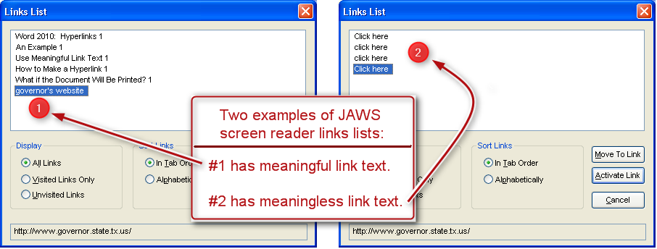
All too often, we see links in a document with the text “Click Here”. If the author writes “Click Here” for all links, guess what the screen reader will say? That’s right, a tiresome refrain of “Click Here, Click Here, Click Here.” When we link with words like “Click Here” or “Read More,” we aren’t giving the user any useful information about that link. And that’s not accessible.
To make the links accessible, use contextual links, or links made of meaningful words that describe the hyperlink. Use concise and descriptive text and not the actual hyperlink address or URL. In fact, the Word Accessibility Checker will flag URLs as unclear text. In our earlier example, it is very clear to the assistive-technology user that this is a link to the governor’s website. The sighted reader gets the same benefit.

How to Make a Hyperlink
To make a hyperlink, follow these five simple steps:
- First, select the meaningful text that will be used for the link.
- Then, click on Hyperlink in the Productivity/Accessibility ribbon, or right-click the selected text and then select Hyperlink, or press Control+K to open the Insert Hyperlink dialog.
- Next, select the appropriate Link to choice on the left side of the Insert Hyperlink dialog box. You can also verify your text selection at the top of the box.
- Now, add the complete URL in the Address field at the bottom and click OK.
- Finally, check that your link goes to the proper location.

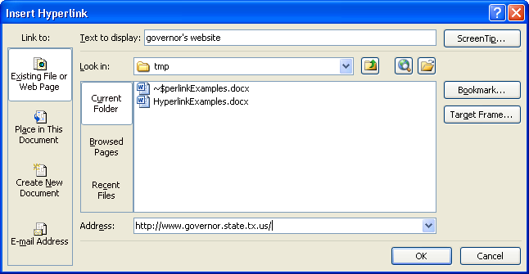

What if the Document Will Be Printed?

Some documents are used both on the screen and in print. We haven’t figured out how to make clickable links on a piece of paper yet, but there is a very simple solution: add the long URL as a footnote or endnote, as we have done at the end of this module. That way, the text is not cluttered with URLs, and they are easy to find in printed format.
This concludes our module on “Hyperlinks.”
Now here’s the end note we promised:

http://www.governor.state.tx.us

