Word 2010: How to Make Figures Accessible
Contents
Word 2010: How to Make Figures Accessible 1
Introduction 1
How Do I Position a Figure? 1
How Do I Add Alt Text? 2
Is a Picture Really Worth a Thousand Words? 2
Would a Caption be Helpful? 3
Recap 4

Introduction
Photos, drawings, charts, graphs, and other figures in our documents can add value to our communications, but we must be sure the information contained in them is available to people with disabilities. Just three easy steps are necessary:
- position the figure properly,
- add alt text, and
- include a caption.
Making figures accessible in Word 2010 is easier than ever. At the right side of the Productivity/Accessibility ribbon is the Pictures section. This is where you can conveniently insert and position your figure and add a border and alt text.

How Do I Position a Figure?
Select the figure, click Layout, and choose the In Line with Text option. That’s it. (You can also right-click on the picture and open the Wrap Text menu to find the In Line with Text option. Using the keyboard, focus on the picture and press Shift+F10, W, I.)
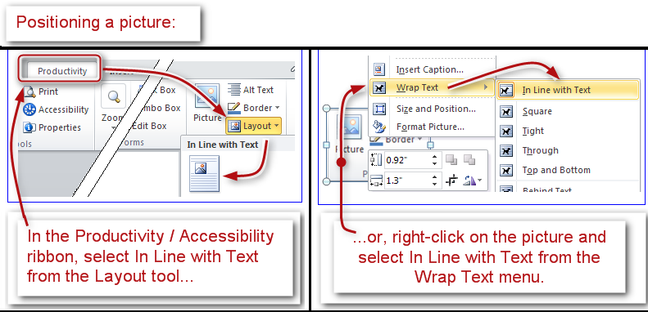
Figure 1, Positioning a picture.

How Do I Add Alt Text?
With the figure selected, choose the Alt Text option from the Pictures section. (You can also right-click the picture and select Format Picture from the context menu, then choose the Alt Text tab in the Format Picture dialog. With the keyboard, focus on the picture and press Shift+F10, O, then Down Arrow to select the Alt Text tab.)
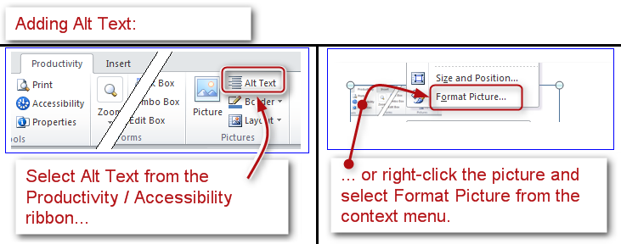
Figure 2, Adding Alt Text.
The Alt Text dialog box will open. There are two boxes in this window: Title and Description. Leave the Title box empty and add a brief description of your figure in the Description box.
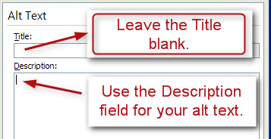
Figure 3, Alt Text fields.
If your document originated in an earlier version of Word, it will open in the Compatibility Mode and the process will be slightly different. When the Alt Text dialog box opens, select the Alt Text tab, then enter a brief description in the alt text field.

Is a Picture Really Worth a Thousand Words?
Sometimes figures are extremely important to the content of a document. They provide nonverbal information to readers. As the document author, you must decide whether a picture contains information that will be useful to the reader of the document.
If the information in an image adds meaning to the document, explain the figure succinctly but accurately in the alt text. However, if an image is there merely for decorative purposes and does not add meaning to the text, type a pair of quotation marks (“”) in the alt text. This lets the reader know that the alt text was not forgotten.
If you add a very complex image, such as a graph or chart, it may not be possible to describe the picture in a few words. If that is the case, it may make sense to repeat the information from the image in the page text that follows the image. Everyone who reads the document can then focus on the important information found in the image, including assistive technology users. For example, if a graph of quarterly earnings is followed by a paragraph that describes the earnings report, then the alt text for the image might just say "Quarterly earnings, details follow in page text."
If you are in doubt about how to manage the alt text for a complex image, contact an agency accessibility specialist for help.

Would a Caption be Helpful?
Yes! Alt text is only valuable to a person using a screen reader. Captions, on the other hand, are useful for everyone. Even if the document is printed, captions are still there to give some insight about the figure. We recommend their use.
To add a caption to your figure, select the Caption option from the Tables section of the Productivity/Accessibility ribbon. (You can also right-click the picture and select Insert Caption from the context menu, then choose the Alt Text tab in the Format Picture dialog. With the keyboard, focus on the picture and press Shift+F10, N to open the Caption dialog.)
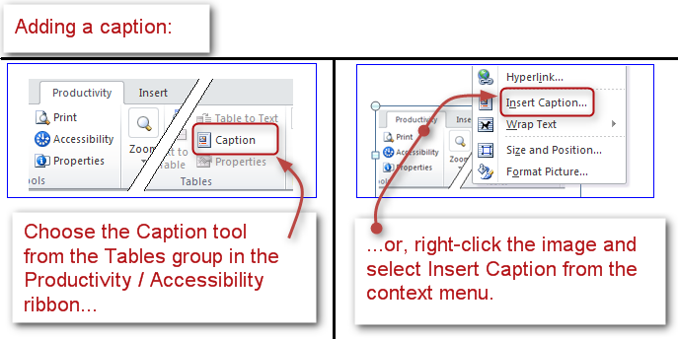
Figure 4, Adding a caption.
Enter the caption information in the proper field. In the Label field, select Figure.
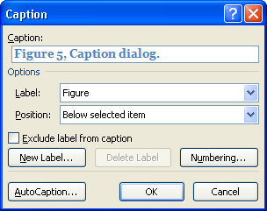
Figure 5, Caption dialog.

Recap
Making figures accessible is really very easy.
- Position the figure to be in line with text.
- Add a concise description if the image is meaningful—or a pair of quotation marks with no content (“”) for decorative images.
- Add a caption.
This concludes our module on how to make Figures accessible.

