Word 2010: Templates & Styles, the Basics
Contents
Word 2010: Templates & Styles, the Basics 1
How Documents are Made 1
Templates Overview 2
Modifying an Existing Template 2
Creating a New Template 2
Styles Overview 3
Creating and Modifying Styles 3

How Documents are Made
Before you type the first word in a new document, a number of decisions must be made. The size and orientation of the page, the margins, type face, font size, and line spacing all have to be specified. This collection of specifications that determine the appearance of a document is known as a template. Every document created using Word, even the simplest, is based on a template.
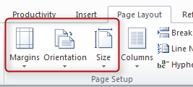
Microsoft Word uses a default template, called the Normal template, when you create a new blank document. Unless it has been modified, the Normal template specifies a letter-size page with the portrait orientation, and one-inch margins on all sides.
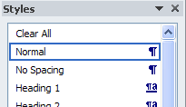
A template also supplies a set of styles for a new document. In the Normal template, the default style is the Normal style, which uses a default type face, font size, and line spacing. However, there are many other styles to choose from, including the heading styles that define the document’s structure, which we discussed in another module. If you want to change the appearance of what you type, you can apply a different style, modify an existing style, or even create a new style.
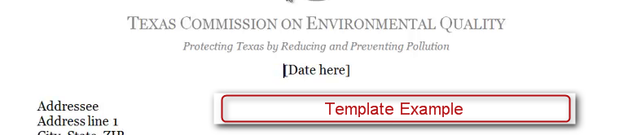
There are template options, too. You may already have several special-purpose templates on your computer. In addition to the page format and the styles, a template may supply standard text. Your organization may have created customized templates, such as a letterhead for formal correspondence. Also, you can make or modify your own templates for documents you create often, and keep them on your hard drive.

Templates Overview

Modifying an Existing Template
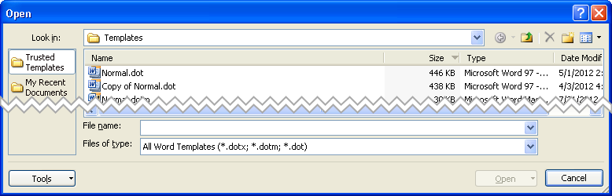
To modify an existing template, you need to open it. In the Productivity/Accessibility Ribbon, click Open to get to the Open dialog. (You can also get to this dialog by pressing Alt+F, then the letter O.) Then from the Files of type field File name field, select All Word Templates (*.dotx; *.dotm; *.dot). In the File name drop-down, locate and select the template you wish to customize. Make any changes you want to the page specifications and styles. Then, save your changes.

Creating a New Template
To create a new template, you can start with an existing template, or a new or existing document.
If you start with an existing template, open the template, make the changes you want, and save it with a new name.
If you start from a document, open the new or existing document, and make your changes to the page formatting and styles. You may include text that appears each time a new document is based on the template, or it may be saved with no text.
Next, when you save the template, select Word Template from the Save as type pull-down list. Check that it has the correct extension:
- .dotx is the file extension used for templates in Word 2010 and 2007
- .dotm is for a template with Macros built into it
- .dot is the extension you should use if you will be sharing your template with users who have Word 97-2003. Documents based on this type of template will open in Word 2010 in the Compatibility Mode, which means you will not have all the Word 2010 features available to you.
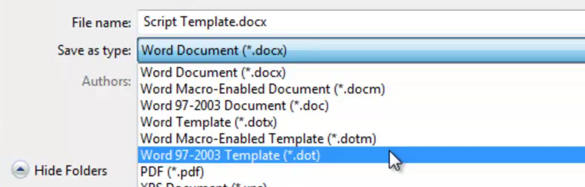
Finally, give your new template a descriptive name in the File name text box. Be sure to save it in the location you prefer before you click Save.

Styles Overview
Use styles for all your text formatting. Recall from the module on Requirements to Make a Document Accessible that a document’s structure is determined by applying heading styles. Don’t use the controls in the Font or Paragraph sections of the Home or Page Layout ribbons because making formatting changes that way interferes with accessibility. That also makes it difficult and confusing to revise your document styles later.
To open the Styles pane, click on the Styles button in the Structure section of the Productivity/Accessibility ribbon. You can view how your text will look before you apply a style by checking the box next to Show Preview at the bottom of the Styles pane.
There are two types of styles:
- Paragraph Styles (also known as Block Styles) are identified by the paragraph symbol after the style name. To apply a paragraph style, place your cursor anywhere in the paragraph in front of the paragraph marker, and then click on the style name.
- Character Styles are identified by the lower-case a after the style name. To apply a character style, highlight the desired text, then click on the style name.
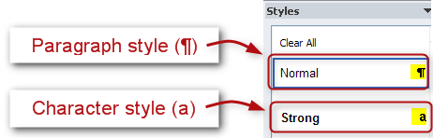
When applying styles, remember that the last-applied style determines the formatting. Also, when you apply a character style over a paragraph style, the character style will be dominant.

Creating and Modifying Styles
You may want to change the appearance of an existing style, or even create a new one. Microsoft offers a variety of methods for doing either. The following examples will get you started.

Create a New Style
If you need to create a new style, the easiest way is to start with an existing style similar to the one you want to create. In the Styles pane, click on the style you want to base your new style on. Click the New Style button at the lower-left corner of the pane.
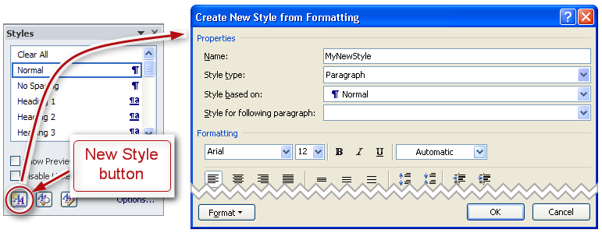
When the Create New Style from Formatting dialog box opens, type a name for the new style in the Name box. Make the changes you want to your new style, and click OK.
Word’s Help function will introduce you to other ways to create new styles in Word.

Modify an Existing Style
With the Styles pane open, hover your cursor over a style name, but don’t click on it yet. When you move the cursor over a style name, a box appears along with a drop-down arrow on the right side. Click the arrow, and then the Modify… option. The Modify Style dialog box will appear.
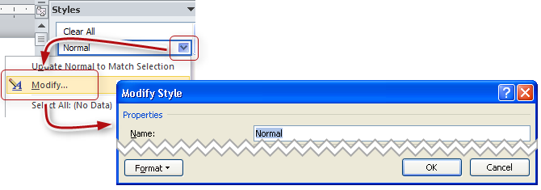
All of the options for defining a style can be found in this box. Make your changes, then click OK. Take a few minutes to explore all the control you have over your style. Your options may not be limitless, but I’ll bet you can’t count them all the first time through!
Word’s Help function will introduce you to other ways to modify styles in Word.
Conclusion
This concludes Templates and Styles, the Basics.

