Word 2010: How to Make an Old Document Accessible
Contents
Word 2010: How to Make an Old Document Accessible 1
Five Easy Steps 1
Step 1: Planning 1
Step 2: Save the Original Version 2
Step 3: Open Windows 2
Step 4: Eliminate All Previous Formatting 2
Step 5: Style Your Document 3
Conclusion 3

Five Easy Steps
Your boss just told you to make an old document accessible. What are you going to do? If you follow these five simple steps, you will have an accessible document in no time!

Step 1: Planning
This step is essential. The more time you invest in planning, the less time you’ll have to spend fixing the document later. Here are some important questions to keep in mind: How will the new accessible version look? Does your manager want it to look as close to the original as possible, or should you update its appearance? Is it already structured and organized correctly? If not, how will you make the necessary changes?
When you’ve made your planning decisions, make sure your template will give the look you want and meet the accessibility requirements. And remember, you can always modify an existing template, or just create a new one.
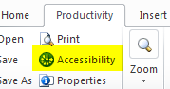
A helpful guide is the Accessibility Checker, located at the left side of the Productivity or Accessibility Ribbon, in the File Tools section. It informs you where to improve accessibility within the document, as well as how to fix it. For more information, see the Accessibility Checker module of this training.

Step 2: Save the Original Version
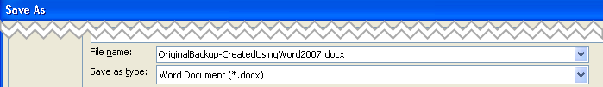
Save a copy of the original as a back-up in case you make such a big error that you have to start over. You should give it a new, descriptive name so that you will be able to distinguish it from the working file.

Step 3: Open Windows
You should open three windows in this step:
- First, open your working document. Make sure it is not the one you saved as your back-up in the previous step.
- Second, open a new Word document. This is the time to choose a template, either the default Normal template, or another template that you decided on during your planning. It will become your new, accessible file.
- Finally, open a text editor. This will be used to get rid of the old formatting. Notepad is usually a good choice, unless you have another preference.
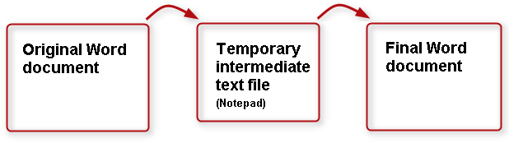

Step 4: Eliminate All Previous Formatting
If you like to use keyboard shortcuts, these will be handy in the following steps:
- To Select All, press the keys Control+A.
- Copy is Control+C.
- Paste is Control+V.
Here are the steps:
- Select and copy all of the content in the working copy.
- Then, paste the contents into the text editor. This action removes all previous formatting.
- Select and copy the text from the text editor.
- Next, paste the text into the new Word file. Give the file a new name and save it.
- Finally, close the text editor, so that the working copy and the new, unformatted Word document are the only documents open.

Step 5: Style Your Document
In this step, apply styles to the unformatted document, to give it the look you want and the structure it needs to be accessible. Because the new, plain text document lacks formatting, refer to the working copy as a guide for determining structure and choosing styles.
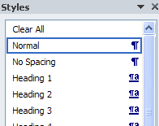
Here’s a shortcut you may want to consider as you format your new version: If your document is reasonably simple, you can start by selecting all the text and applying the Normal or Body Text style. Then, go back and add headings and other styles to appropriate lines.
And don’t forget, you can never hit ‘save’ too many times!

Conclusion
This concludes our module on how to make an old document accessible.

