Word 2013 & 2016: Using the Accessibility Checker
Contents
Word 2013 & 2016: Using the Accessibility Checker 1
Introduction 1
What is the Productivity/Accessibility Tab? 1
What is the Accessibility Checker? 1
The Checker Only Works With Office 2013/2016 Format 2
Converting an Older Document to 2013/2016 Format 2
Open the Checker 2
If the Productivity Tab is Not Available 2
Using the Checker 2
The Accessibility Checker Task Pane 3
Do You Have To Fix All of the Problems? 3
Alt Text Example 3
Excel and PowerPoint 4
Conclusion 4

Introduction
This module provides an introduction to the Office 2013 & 2016 Accessibility Checker tool. We will look at what the accessibility checker is, how to use it, and what it can do for you.

What is the Accessibility Checker?
The checker assists with finding accessibility errors in Word, PowerPoint, and Excel.
Although the checker can find a variety of issues, it cannot find every possible error. If you get a clean bill from the accessibility checker, you still need to follow the rules for creating accessible Office files. The other modules in this training series give you more information on how to create accessible documents.

The Checker Only Works With Office 2013/2016 Format
Here we are editing a Word document that was created using an earlier version of Office. You can see the words "Compatibility Mode" next to the file name.
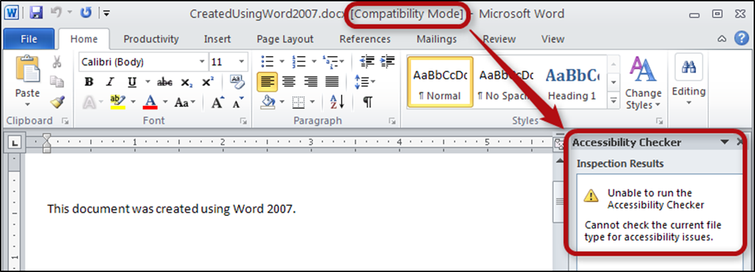
When we run the accessibility checker, the message in the Inspection Results area tells us that it "cannot check the current file type for accessibility issues."
The checker works on documents that are created or saved using Office 2013/2016 format. If you open a Word document and you see "Compatibility Mode" written next to the file name at the top of the window, you will need to convert the document to Word 2013/2016 format before you can use the accessibility checker.

Converting an Older Document to 2013/2016 Format
One way to convert an older document to Word 2013/2016 format is to use the Save As function to save the document into the new file format.
Word also provides another way to do this: the Convert option found on the File tab. Open the File tab and select Info on the left sidebar. You will see a Compatibility Mode section that contains a big button labeled “Convert.” Select that button to convert your document. If you are using the keyboard, press Alt+F, I, K to select the convert option.
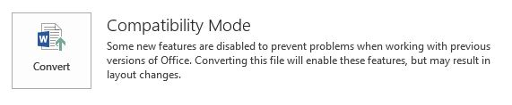
After you convert the file, you can see the checker now works. In this case, the Inspection Results show that no accessibility issues were found.
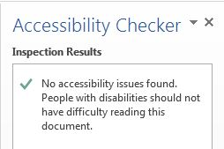

Open the Checker
The easiest place to find the checker is in the Word Productivity Tab in the File Tools group. If you are using the keyboard, you can open the checker by using the following shortcuts. In Word 2013 press Alt+Y, Y1. In Word 2016 press Alt+Y, Y2, Y8. (This keyboard shortcut might be different if you have more than one custom tab on your system.)
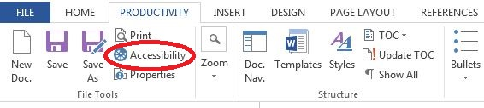
Select the Accessibility tool option, and the task pane displays on the right-hand side of the Word window.

If the Productivity Tab is Not Available
If you don't have the Productivity tab installed, or if you are editing a PowerPoint or Excel file, here's how you can find the checker.
- Click on the File tab in the ribbon.
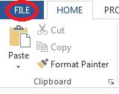
- Make sure the Info page is selected in the left sidebar. In the main information area, find the section called "Prepare for Sharing."
- Click on the Check for Issues button, and then select Check Accessibility from the resulting dropdown box.
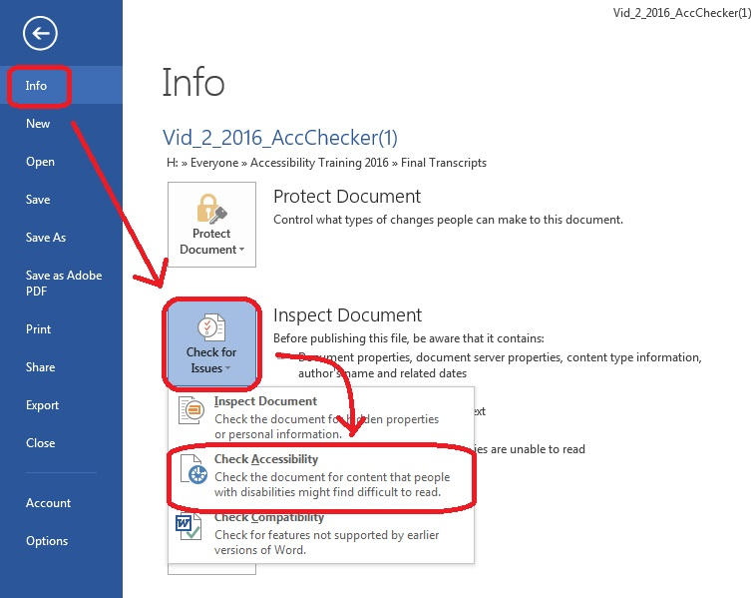
To open the checker using the keyboard, press Alt+F, I, I, A.

Using the Checker
This example shows how to use the checker using a file that contains a number of common accessibility errors.
When you activate the checker, it presents a list of all the issues it finds. As you make changes in the document, Word automatically updates the list.

The Accessibility Checker Task Pane
The task pane is divided into two sections: Inspection Results and Additional Information. If you are using the keyboard, you can navigate to the Accessibility Checker Task Pane using the F6 key, then using the up and down arrow keys as needed.
The Inspection Results section shows the list of accessibility issues found in the document. If you click on an issue, the Additional Information section gives you details on why this is a problem and tips on how to fix it.
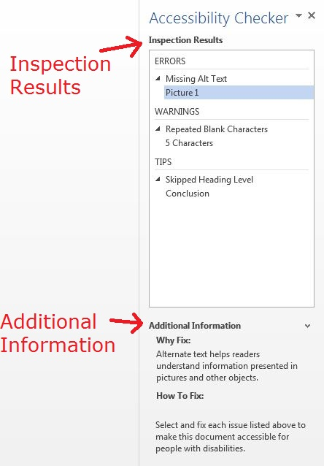
To hide the Additional Information section, click the down-arrow to the right of the Additional Information label. This lets you see more of the Inspection Results, which are divided into three categories:
- Errors are the most serious problems. They indicate content that people with disabilities are unable to read,
- Warnings indicate content that people will find difficult to read, and
- Tips indicate content that people might find difficult to read.

Do You Have To Fix All of the Problems?
The Accessibility Checker gives one false result consistently: it tells you to add alt text to tables. Although Word will let you enter text in a field called Alt Text, that information serves no purpose. So you should ignore an alt text error for a table.
You should correct all other issues listed, if possible. If you have any questions, ask your local accessibility specialist.

Alt Text Example
Now that the checker has given you a list of issues, what do you do? Let's look at an error listed by the checker.
Notice that the issues are listed in categories. The first category in our list is Missing Alt Text. Alt text must be provided for any element that cannot be fully described by a screen reader. In this example, two elements in the document are missing Alt Text: Picture1 and a table.
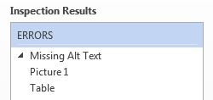
To find the error in the document, click on an element in the error list. Word will move to the place in the document where the error was found. By clicking on Picture 1, the picture moves to the top of the window.
If you are unsure how to fix the error, remember that the checker also provides more information. If the Additional Information area is not visible, click on the up-arrow character next to the Additional Information heading at the bottom of the task pane. The additional information not only explains why the problem should be fixed, but also how to fix it.
If you would like to learn more about alt text for images, you can review the Word module, How to Make Figures Accessible, in this training series.
After you fill in the Alt Text, notice that the error has disappeared from the Inspection Results, letting you move on to the next error, if any.

Excel and PowerPoint
We have been using Microsoft Word to demonstrate the accessibility checker, but the checkers in PowerPoint and Excel work exactly the same way. Just as with Word, additional information is provided to help you correct any errors that are listed.

Conclusion
In this module you have learned that Office provides a checker to help you find accessibility issues in your Microsoft Word, Excel, and PowerPoint files.
The checker not only provides a list of potential accessibility errors, but also gives you hints on how to correct the problems. However, it cannot find every possible problem in your Office document. Use other tools such as the Document Navigation tool to help you determine if there are styling issues that were not found by the checker.
If you use these tools and follow the basic rules you have learned for creating accessible Office documents, your documents will be usable by the widest possible audience.
This concludes our module on Using the Microsoft Office Accessibility Checker.

