Word 2010: Productivity /Accessibility Ribbon Explained

Contents
Word 2010: Productivity /Accessibility Ribbon Explained 1
What is the Productivity/Accessibility Ribbon? 2
Accessibility is Important Too! 2
Where to Find the Ribbon 2
Activating the Ribbon 2
Installing the Ribbon 3
Using the Productivity Ribbon 3
File Tools 3
Zoom 3
Structure 4
Lists 4
Layout 4
Tables 4
Language & Links 5
Forms 5
Pictures 5
Conclusion 5

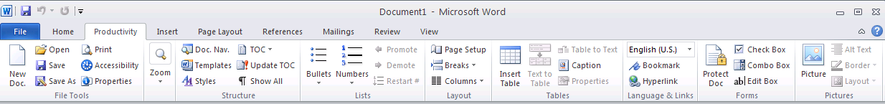

What is the Productivity/Accessibility Ribbon?
Microsoft Office 2010 continues the use of “ribbons” introduced with Office 2007. Ribbons replace the toolbars used in older versions of Office. If the ribbons are new to you, it may take some time to get used to the concept.
The Productivity/Accessibility Ribbon is a collection of tools commonly used when creating Word documents. Several Texas state agencies collaborated in creating the ribbon to help reduce confusion and eliminate the need to search through multiple ribbons for the tools. Some agencies call it the Productivity Ribbon and others call it the Accessibility Ribbon (its original name). It’s the same tool and either name is okay. For simplicity, we call it the Productivity Ribbon for the rest of this learning module.
The Productivity Ribbon provides quick access to frequently used tools, including the tools to help you make your documents as accessible as possible.

Accessibility is Important Too!
An accessible document is one that can be used by everyone, including people with disabilities. Making our documents accessible allows people with disabilities to participate in routine activities. When you use the correct tools in Word 2010, it’s just as easy, and maybe even easier, to create an accessible document as it is to create one that is not accessible.

Where to Find the Ribbon
Look at the ribbon tabs at the top of the Word window. If you see the word Productivity listed, the ribbon is installed and ready to use.
By default, the ribbon appears between the Home tab and the Insert tab, on the left end of the ribbon. However, some agencies may choose a different location. Other agencies might choose to install the ribbon in a deactivated state, so you may need to activate it before you can use it.

Activating the Ribbon
To see if the ribbon is installed but not active, open the "customize the ribbon" dialog in Word. Here are two ways to check if the Productivity Ribbon is installed and, if it is, to activate it.

Using a Mouse
If you are using a mouse:
- Right click your mouse anywhere in the ribbon at the top of the Word window. This will open a context menu showing, among other things, a Customize the Ribbon option.
- In the context menu, click on the Customize the Ribbon option. This will open the Customize Ribbon dialog.
- In the Main Tabs list, look for a checkbox labeled Productivity (Custom). If you see it, the ribbon is installed and you only need to activate it. If you do not see the Productivity checkbox, then you must install the ribbon to use it.
- To activate the installed ribbon, click the Productivity (Custom) checkbox. If the box is already checked, the ribbon is already active. (Verify that the checkbox is checked before proceeding.)
- Click the OK button at the bottom of the dialog to finish. That's it, you're done!

Using the Keyboard
If you are using the keyboard to activate the ribbon:
- Press Alt, F, then T, then C. This will open the Customize Ribbon dialog.
- Press Alt+B, then Tab to jump to the Main Tabs list.
- Use the Arrow keys until Productivity (Custom) is highlighted. (Use Down Arrow and Up Arrow, as needed.) If you do not see the Productivity checkbox, then you must install the ribbon to use it.
- To activate the installed ribbon, press the Space bar to select the Productivity (Custom) checkbox. (Verify that the checkbox is checked before proceeding.)
- Press Enter to finish. That's it, you're done!
After it is activated, you will see the Productivity tab between the Home and the Insert tabs in the ribbon.

Installing the Ribbon
If the Productivity Ribbon is not installed on your machine, you can install it yourself. Check the resources included with this training module for instructions on installing the ribbon.

Using the Productivity Ribbon
To open the ribbon, use the mouse, click on the Productivity tab or if you are using the keyboard, press Alt, Y1. (If you have multiple custom ribbons installed in your Word application, the keyboard shortcut may change. Alt, Y1 will work if the Productivity Ribbon is the first custom ribbon in the list.)
The ribbon is divided into several sections, labeled across the bottom of the ribbon: File Tools, Zoom, Structure, Lists, Layout, Tables, Language & Links, Forms, and Pictures. Details about the tools found in the ribbon are discussed in the other learning modules. But let's look briefly at each section.

File Tools
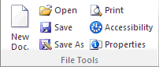
The File Tools section includes the tools to create a new document, open an existing document, save or print a document, or update the document properties. It also gives you quick access to the new accessibility checker tool. View the Accessibility Checker learning module for an introduction to that tool.

Zoom
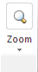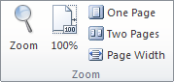
The Zoom tools let you change your magnification level when viewing a document, so you can make the text larger or smaller depending on your needs. These tools change how you are viewing the document on your screen. They do not change document font sizes.

Structure
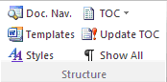
The tools in the Structure section allow you to view and change structural elements in your document, such as the text styles, headings, and table of contents. The Templates option lets you quickly change the document template.

Lists
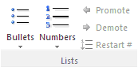
The Lists section contains tools for creating bulleted and numbered lists. Note that if a tool is grayed out, or not available, it just means that you are not currently editing an element that can use that tool. Here, the Promote, Demote, and Restart Number items are not available because we’re not currently editing a list in the document.

Layout
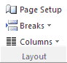
The Layout section includes the tools for setting page or section breaks, or changing to single- or multiple-column formats, and also gives you a shortcut to the Page Setup dialog.

Tables
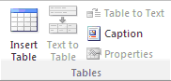
The Tables section contains tools for creating and editing data tables. You can insert a new table, convert existing text to a table or a table back to text, add a caption to your table, or open the table properties dialog.

Language & Links
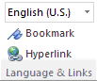
The Language & Links section has tools to set the language of the document or a section of text within the document, and to set bookmarks and hyperlinks in the document.

Forms
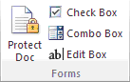
The Forms section includes tools related to simple forms. Keep in mind that not all forms controls in Word are accessible to people using screen readers, so you should use the elements provided here to ensure that your forms can be used by everybody.

Pictures
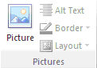
The Pictures section has tools that let you insert a picture into your document, to add alt text to the picture so that people using a screen reader know what the picture is, to add a border, and to set the layout for the picture. Remember that you should normally use the inline layout option.
That covers all of the sections of the Productivity ribbon.

Conclusion
In this module you have learned that a Productivity Ribbon is available for Word 2010, how to find it, and which tools are found in the ribbon. Other modules in this training series provide more detail on using the tools found in the Productivity Ribbon.
If you are just moving to Word 2010 from an older version of Microsoft Office, having these commonly used tools in a single ribbon will not only make it easier to become productive when using Word 2010, but as an added benefit, will help you make your documents more accessible to people with all levels of ability.

